CHAPTER 1
INTRODUCTION

1.1 BACKGROUND
In the present era, intelligent systems are transforming the way human beings interact with machines, appliances, and digital environments. The traditional mode of operating household and industrial equipment has gradually shifted from manual control toward automated and adaptive control. This transition has been supported by advancements in artificial intelligence, embedded systems, computer vision, machine learning, and the Internet of Things. As a result, modern automation is no longer limited to simple on/off operations or fixed programmed actions, but is increasingly capable of understanding context, analyzing human behavior, and responding dynamically to changing situations.
Among the many goals of intelligent automation, one of the most important is the improvement of human comfort and convenience. Human beings do not always experience comfort in the same way, because comfort is influenced not only by environmental factors such as temperature and humidity, but also by emotional and psychological conditions. A person who is angry, stressed, tired, sad, or relaxed may experience the same physical environment differently. However, most conventional electrical appliances are designed to react only to direct user commands or simple sensor readings, without considering the emotional state of the person using them. This creates a gap between machine operation and actual human-centered comfort.
Emotion recognition has therefore emerged as a promising field that can bridge this gap. Human emotions are often reflected through facial expressions, tone of voice, body posture, and physiological signals. Among these, facial expression is one of the most natural and commonly observed indicators of emotion. A person’s face can convey feelings such as happiness, sadness, anger, fear, surprise, and neutrality without the need for verbal communication. Advances in computer vision and deep learning have made it possible for machines to detect and interpret these expressions with considerable accuracy. This capability opens the door for a new generation of systems that are not only automated but also emotionally aware.
An emotion-aware system can monitor facial expressions through a camera, analyze them using software algorithms, and make control decisions based on the identified emotional state. Such systems are becoming increasingly relevant in smart homes, healthcare support systems, adaptive learning platforms, customer service technologies, and human-machine interaction applications. They have the potential to personalize user experiences, reduce manual effort, and create more responsive environments. In the context of home automation, emotion-aware control offers an innovative way to make daily-use devices respond more intelligently to the user’s mental and emotional condition.
The fan is one of the most frequently used household appliances for maintaining thermal comfort. In homes, offices, hostels, hospitals, and classrooms, fans are used regularly to provide air circulation and cooling support. Despite their widespread use, fans are usually operated through manual regulators, speed controllers, or remote control units. In some modern systems, automatic control is achieved using environmental sensors such as temperature sensors. Even so, these systems primarily respond to physical temperature changes and do not reflect the emotional comfort or discomfort of the person present in the space. Therefore, there is a clear opportunity to develop a smarter control approach that considers the human emotional state as part of the decision-making process.
The proposed research explores this idea through the design and development of an Emotion-Based Load Fan Speed Control System Using Facial Expression Recognition. The system captures the user’s face through a camera, processes the facial image using Python-based emotion detection algorithms, and then sends the detected emotion to an Arduino Uno microcontroller. Based on the result, the microcontroller controls the speed of the fan and activates the appropriate LED indicator. In the developed model, emotions such as anger, sadness, and happiness are mapped to different control outputs. For example, anger results in high fan speed with red LED indication, sadness produces medium fan speed with yellow LED indication, and happiness turns the fan OFF with green LED indication.
This proposed work reflects the integration of several engineering domains. It combines computer vision for face capture, machine learning or deep learning techniques for emotion analysis, embedded system programming for control logic, and electronic interfacing for fan speed control and user indication. Such integration not only demonstrates the practical value of interdisciplinary engineering but also provides a foundation for future emotion-aware smart home technologies. The project thus represents a small but important step toward human-centered automation, where machines adapt themselves according to human feelings and expressions rather than relying solely on physical environmental parameters.
1.2 NEED FOR EMOTION-BASED AUTOMATION
The need for emotion-based automation arises from the increasing demand for more intelligent, personalized, and responsive systems in daily life. Traditional automation systems are primarily rule-based, meaning they perform predefined actions when a specific condition is met. For example, a fan may turn ON if the room temperature exceeds a threshold, or a light may switch OFF after a timer expires. While these methods improve efficiency to some extent, they remain limited because they do not understand the user’s emotional or psychological context.
In real-life situations, people often seek comfort that is closely linked to their mood. An angry or irritated person may prefer stronger airflow to feel calmer and more comfortable. A sad person may prefer a moderate environment, while a happy and relaxed person may not need active cooling at all. Existing control systems do not usually adapt to such emotional differences. They assume that all users respond similarly to the same physical environment, which is not always true. Therefore, incorporating emotional intelligence into appliance control can offer a more personalized user experience.
Another important reason for developing emotion-based automation is the reduction of manual effort. In many everyday settings, users repeatedly adjust devices such as fans, lights, and air conditioning systems depending on how they feel. This manual intervention may seem minor, but it can become inconvenient over time. A system that detects the user’s emotion and performs the required control action automatically can make interaction smoother and more natural. Instead of relying on continuous manual input, the user can benefit from passive and intelligent automation.
Emotion-based automation is also significant from the perspective of human-machine interaction. Traditional control interfaces depend on buttons, switches, remotes, touchscreens, or voice commands. These interfaces require deliberate action from the user. In contrast, emotion recognition introduces a non-verbal and natural interaction mechanism. It allows machines to sense facial cues and respond accordingly. This can be especially useful in environments where manual interaction is inconvenient, such as healthcare rooms, assistive technology setups, or smart living spaces designed for elderly users.
Furthermore, emotion-based control has strong relevance in the development of future smart home ecosystems. Smart homes are expected to become more adaptive, predictive, and user-centric. Integrating emotional awareness into appliance operation can help create a more pleasant and supportive environment. For example, a smart home may use emotion recognition not only to adjust fan speed but also to regulate lighting, music, room temperature, or notifications based on the occupant’s mood. The proposed project aligns with this broader vision by demonstrating one practical application of emotion-driven automation.
1.3 PROBLEM STATEMENT
Conventional fan control systems are generally based on manual operation or simple environmental sensing. In manual systems, the user has to adjust the speed regulator or switch whenever a change in airflow is required. In automatic systems, fan speed may be varied based on temperature or humidity readings. Although these methods provide basic functionality, they do not consider the emotional condition of the user, which can significantly influence comfort and preference.
The absence of emotional intelligence in conventional appliance control systems leads to a lack of personalization and adaptability. A fan operating purely on temperature readings may not satisfy the comfort needs of a user whose emotional state demands a different level of airflow. This limitation reduces the effectiveness of automation and keeps the system dependent on either fixed sensor logic or repeated manual intervention.
In addition, most affordable household automation solutions are designed around physical environmental parameters and do not include advanced human-centered inputs such as facial expressions or emotional states. As a result, there is a need for a low-cost, practical, and intelligent system that can detect the user’s facial emotion in real time and automatically control a household appliance based on the detected emotion.
The problem addressed in this thesis is therefore the lack of a smart and emotion-aware fan control mechanism that can automatically adjust fan speed according to the user’s facial expression. The proposed work aims to solve this problem by integrating camera-based facial emotion recognition with Arduino-based fan speed control and visual status indication.

1.4 AIM OF THE PROJECT
The main aim of this project is to develop an intelligent fan speed control system that operates according to the user’s facial emotion. The system is intended to capture facial expressions in real time, analyze them using Python-based emotion recognition, and then automatically adjust fan speed using an Arduino-based embedded control setup. Through this approach, the project aims to improve user comfort, reduce manual effort, and demonstrate the practical use of emotion-aware automation in smart environments.
1.5 OBJECTIVES OF THE STUDY
The objectives of the proposed project are as follows:
- To design a system that captures human facial expressions using a camera.
- To develop a Python-based backend for real-time facial emotion detection.
- To identify specific emotional states such as anger, happiness, and sadness from captured facial images.
- To transmit the detected emotion to an Arduino Uno for hardware control.
- To control the speed of a fan automatically based on the identified emotion.
- To provide visual indication of detected emotion using LEDs.
- To display the detected emotion and system status on an LCD screen.
- To create a low-cost and user-friendly prototype for emotion-aware appliance automation.
- To demonstrate the integration of computer vision, embedded systems, and smart control in a single application.
1.6 SCOPE OF THE STUDY
The scope of this project is focused on the development of a prototype model for controlling fan speed based on facial emotion recognition. The system uses a camera to capture the user’s facial expression, Python code for analyzing emotions, and an Arduino Uno for executing control actions. The project is limited to three emotional categories: anger, sadness, and happiness. These emotions are mapped to predefined fan responses such as high speed, medium speed, and OFF condition respectively.
The hardware scope includes the use of a camera, laptop or computer, Arduino Uno, motor driver, DC fan, LEDs, LCD display, power supply, and supporting circuit components. The software scope includes Python programming for emotion detection and Arduino programming for control logic. The system is implemented as a proof-of-concept model and is intended primarily for academic, demonstration, and prototype purposes.
The project does not include large-scale deployment, cloud integration, or advanced multimodal emotion recognition. It also does not attempt to recognize a full range of complex emotions beyond the selected categories. Nevertheless, the developed system provides a strong foundation for future enhancements and practical extensions.
1.7 SIGNIFICANCE OF THE STUDY
The significance of this study lies in its contribution to the growing field of intelligent and human-centered automation. By combining facial emotion recognition with appliance control, the project introduces an innovative method for improving user comfort in a natural and interactive way. Instead of relying solely on environmental conditions or direct manual operation, the proposed system allows an appliance to respond according to the emotional expression of the user.
From a technical perspective, the study demonstrates the successful integration of multiple domains, including computer vision, artificial intelligence, embedded systems, and electronics. This makes the project valuable for academic learning and applied engineering research. Students and researchers can use the project as a reference model for understanding how software-based recognition systems can be linked with hardware control mechanisms.
From a social and practical perspective, the project has potential applications in smart homes, healthcare support environments, office automation, and human-machine interaction systems. Emotion-aware devices may help create more supportive living environments, especially in cases where user comfort and convenience are important. The work also contributes to the broader vision of developing machines that understand and adapt to human needs more naturally.
1.8 OVERVIEW OF FACIAL EMOTION RECOGNITION
Facial emotion recognition refers to the process of identifying human emotions based on facial expressions using computational methods. It is an important branch of affective computing, which focuses on enabling machines to recognize, interpret, and respond to human emotions. Facial expressions are considered one of the most direct and informative sources of emotional data, since the human face naturally reflects internal feelings through movements of the eyes, eyebrows, lips, cheeks, and forehead.
The process of facial emotion recognition generally involves several steps. First, a facial image is captured through a camera. Second, the system detects the face region in the image. Third, relevant facial features are extracted and analyzed. Finally, a classification algorithm identifies the probable emotional state. In modern systems, deep learning techniques such as convolutional neural networks are often used to improve recognition accuracy by learning features automatically from large datasets.
Facial emotion recognition has many applications, including healthcare monitoring, e-learning, driver safety systems, entertainment, surveillance, customer feedback analysis, and adaptive user interfaces. In the proposed project, it is specifically used as the decision-making input for controlling fan speed. This demonstrates how emotion recognition can be applied not only in software applications but also in embedded automation systems.
1.9 ROLE OF EMBEDDED SYSTEMS IN SMART APPLIANCE CONTROL
Embedded systems play a vital role in modern automation because they provide the hardware platform needed to execute control actions in real time. An embedded system typically consists of a microcontroller or microprocessor programmed to perform specific tasks efficiently and reliably. In smart appliance control, embedded systems serve as the bridge between software intelligence and physical device operation.
In the proposed work, the Arduino Uno acts as the embedded controller. It receives the detected emotion from the Python-based emotion recognition module and then controls the fan, LEDs, and LCD display accordingly. The motor driver is used to handle the electrical requirements of the fan, while the Arduino generates the control signals needed to operate the system safely and effectively.
The use of Arduino Uno offers several advantages. It is low-cost, easy to program, widely available, and suitable for academic prototyping. It also supports integration with sensors, displays, communication modules, and actuators. This makes it an ideal platform for implementing the proposed emotion-based fan control model.
1.10 HUMAN-CENTERED SMART HOME CONCEPT
The concept of a smart home has evolved significantly over the years. Initially, smart homes focused on remote control and scheduled automation of lights, fans, and security devices. Over time, this concept expanded to include sensor-based intelligence, energy management, and device interconnectivity. The next stage of smart home development involves human-centered adaptation, where systems respond not only to physical conditions but also to user preferences, habits, and emotional states.
Human-centered smart homes aim to enhance quality of life by making living environments more responsive and personalized. In such homes, devices can cooperate to create the most suitable environment for the occupant. Emotion-aware control is one aspect of this vision. By allowing appliances to detect and respond to facial emotion, the home environment becomes more sensitive to the needs of the user.
The proposed emotion-based fan speed control system fits within this concept by providing an example of how emotional data can be used for appliance management. Though the prototype focuses on a single load, namely the fan, the underlying principle can be extended to multiple appliances in future smart home designs.
1.11 WORKING PRINCIPLE OF THE PROPOSED SYSTEM
The working principle of the proposed system begins with image capture through a camera placed in front of the user. The camera continuously acquires facial images and sends them to a computer or laptop running the backend Python program. The Python program uses facial emotion detection algorithms to analyze the image and determine the user’s emotional state.
Once the emotion is identified, the corresponding emotion label is transmitted to the Arduino Uno through serial communication. The Arduino interprets the received data and triggers the appropriate output response. If the detected emotion is anger, the fan is driven at high speed and the red LED is turned ON. If the emotion is sadness, the fan operates at medium speed and the yellow LED glows. If the emotion is happiness, the fan remains OFF and the green LED is activated. At the same time, the LCD screen displays the detected emotion and fan status.
This working principle creates a clear relationship between facial emotion input and appliance control output. It demonstrates how digital image analysis can be directly linked with physical automation through microcontroller-based control.
1.12 ADVANTAGES OF THE PROPOSED APPROACH
The proposed system offers several advantages compared to conventional fan control methods. First, it reduces the need for manual speed adjustment by automating the control process based on facial emotion. Second, it introduces personalization into appliance operation, allowing the fan to respond according to the user’s mood rather than relying solely on environmental parameters. Third, it improves the naturalness of human-machine interaction by using facial expression as an input signal.
Another advantage is the low-cost implementation of the system. By using commonly available hardware such as a webcam, Arduino Uno, LEDs, LCD display, and DC fan, the project remains affordable and practical. The use of Python and Arduino IDE also makes software development accessible and flexible. In addition, the system has educational value because it demonstrates the integration of AI and embedded control in a single prototype.
1.13 CHALLENGES IN EMOTION-BASED CONTROL SYSTEMS
Although emotion-based automation offers promising benefits, it also presents certain challenges. One major challenge is the accuracy of facial emotion recognition. Facial expressions may vary between individuals, and factors such as lighting conditions, camera angle, facial occlusions, and image quality can affect recognition performance. Emotions are also complex and may not always be expressed clearly through facial appearance alone.
Another challenge lies in mapping emotions to control actions. Emotional comfort is subjective, meaning that different people may prefer different fan settings for the same emotion. The proposed project uses a fixed mapping for demonstration purposes, but real-world applications may require personalized or adaptive mapping based on user preferences.
Hardware integration can also introduce practical challenges, such as communication delays between software and microcontroller, motor driver limitations, and power management issues. Despite these challenges, the prototype provides a useful demonstration of the concept and serves as a basis for future refinement.
1.14 RESEARCH CONTRIBUTION
The main contribution of this thesis is the development of a practical prototype that connects facial emotion recognition with real-time fan speed control. The project demonstrates how emotional intelligence can be introduced into a simple household appliance using accessible hardware and software tools. It contributes to the study of smart automation by showing that appliance control can be made more interactive and user-aware.
Another contribution is the interdisciplinary integration achieved in the project. The work combines facial image capture, Python-based emotion recognition, Arduino-based embedded control, and hardware actuation. This makes the project a valuable educational and technical reference for future research in affective computing, smart homes, and embedded automation.
1.15 INTRODUCTION TO EMBEDDED SYSTEMS
An Embedded System can be portrayed as dealing with contraption that makes a particular centered showing up concerning. Gadgets, for example, the ventilation system, VCD player, DVD player, printer, fax machine, cell phone and whatnot are occurrences of installed structures. Each of these machines will have a processor and remarkable equipment to meet the particular fundamental of the application near to the installed programming that is executed by the processor for meeting that particular need. The presented composing PC programs are in like way called "firm thing". The desktop/flexible workstation phone a widely profitable PC.
Embedded Systems do a particular errand; they can't be acclimated to do grouped things. Preoccupations, word managing, bookkeeping, programming movement et cetera. In contains Embedded systems have unfathomably kept assets, especially You can utilize it for an assortment of vocations, for example, playing structures need to strife with two or three due dates. A particular occupation must be done inside a particular time. In some installed systems, called relentless structures, the due dates are stringent. Missing a due date may understand a calamity death toll or harm to property. Implanted frameworks are obliged for control. A comparative number of introduced systems work through a battery, the power utilize must be astoundingly low. Some implanted frameworks need to work in outstanding organic conditions, for example, high temperatures and Humidity.
APPLICATION AREAS
Around 99 for each penny of the processors made breeze up in presented frameworks. The presented framework publicize is a champion among the most amazing progression zones as these structures are utilized as a bit of particularly grandstand parcel purchaser hardware, office mechanization, current computerization, biomedical building, remote correspondence, information correspondence, media trades, transportation, military et cetera.
Consumer appliances:
At home we utilize distinctive installed structures which intertwine computerized camera, impelled journal, DVD player, electronic toys, microwave stove, remote controls for TV and air course and cooling system, VCO player, PC redirection bolsters, video recorders and so forth. The present front line auto has around 20 installed structures for transmission control, motor start control, ventilating, course and whatnot. Most likely, even wristwatches are straightforwardly persuading the chance to be especially presented structures. The palmtops are capable installed structures utilizing which we can do various broadly important attempts, for example, playing beguilements and word preparing.
Office automation:
The workplace mechanization items utilizing em installed frameworks are duplicating machine, fax machine, key phone, modem, printer, scanner and so on.
Industrial automation:
Today a noteworthy measure of associations utilizes presented frameworks for process control. These merge pharmaceutical, bond, sugar, oil examination, atomic importance, control period and transmission. The implanted frameworks for mechanical utilize are intended to complete particular attempts, for example, viewing the temperature, weight, wetness, voltage, current and so on., and a while later make genuine move in context of the checked levels to control unmistakable gadgets or to send data to a solidified watching station. In hazardous current condition, where human closeness must be kept away from, robots are utilized, which are modified to do particular occupations. The robots are at the present time winding up being convincing and complete various beguiling and perplexed assignments, for example, outfit get together.
Medical electronics:
In every practical sense every helpful apparatus in the pro's office is an installed structure. These arrangements join symptomatic assistants, for example, ECG, EEG, circulatory strain measuring contraptions, X-column scanners; prepare utilized as a bit of blood examination, radiation, colonoscopy, and endoscopy and so on. Changes in remedial contraptions have cleared path for more correct examination of torments.
Computer networking:
PC sorting out things, for instance, ranges, switches, Integrated Services Digital Networks (ISDN), Asynchronous Transfer Mode (ATM), X.25 and diagram hand-off switches are embedded structures which execute the basic data correspondence traditions. For example, a switch interconnects two frameworks. The two frameworks may run assorted tradition stacks. The change's ability is to get the data packages from moving toward pores, look at the groups and send them towards the objective ensuing to doing principal tradition change. Most frameworks organization sorts of apparatus, other than the end structures (desktop PCs) we use to get to the frameworks, are embedded frameworks.
Telecommunications:
In the field of communicate interchanges, the embedded structures can be organized as endorser terminals and framework outfit. The endorser terminals, for instance, key telephones, ISDN phones, terminal connectors, web cameras are embedded structures. The framework adapt fuses multiplexers, distinctive get to systems, Packet Assemblers Dissemblers (PADs), sate11ite modems et cetera. IP phone, IP entryway, IP protect et cetera are the latest introduced systems that give insignificant exertion voice correspondence over the Internet.
Wireless technologies:
Moves in adaptable correspondences are clearing course for m way for some entrancing applications using embedded structures. The phone is one of the miracles of the latest decade of the 20thcentury. It is a powerful introduced structure that gives voice correspondence while we are advancing. The Personal Digital Assistants and the palmtops would now be able to be used to get the opportunity to sight and sound organizations over the Internet. Compact correspondence structure, for instance, base station controllers, adaptable trading centers are moreover exceptional Embedded Systems.
Security:
Security of people and data has dependably been a noteworthy issue. We have to secure our homes and workplaces; and furthermore, the data we transmit and store. Creating inserted frameworks for security applications is a standout amongst the most lucrative organizations these days. Security gadgets at homes, workplaces, airplane terminals and so on for confirmation and check are installed frameworks. Encryption gadgets are about 99 for each penny of the processors that are made wind up in inserted frameworks. Installed frameworks discover applications in. each mechanical section purchaser hardware, transportation, flight, biomedical building, fabricating, process control and modern robotization, information correspondence, media transmission, barrier, security and so forth. Used to encode the information/voice being transmitted on correspondence connections, for example, phone lines. Biometric frameworks utilizing unique finger impression and face acknowledgment are currently being broadly utilized for client validation in saving money applications and additionally for get to control in high security structures.
Finance:
Budgetary overseeing through cash and checks are right now slowly clearing course for trades using splendid cards and ATM (Automatic Teller Machine, in like manner reached out as Any Time Money) machines. Astute card, of the measure of a Visa, has a little littler scale controller and memory; and it interfaces with the insightful card peruse! ATM machine and goes about as an electronic wallet. Quick card advancement has the limit of presenting a cashless society. It is no deception to express that eyes wherever you go, you can see, or if nothing else feel, crafted by an embedded System.
OVERVIEW OF EMBEDDED SYSTEM ARCHITECTURE
Every embedded system consists of custom-built hardware built around a Central Processing Unit (CPU). This hardware also contains memory chips onto which the software is loaded. The software residing on the memory chip is also called the ‘firmware’. The embedded system architecture can be represented as a layered architecture as shown in Figure.
Figure 1.1: Overview diagram of Embedded system
The working system keeps running over the equipment, and the application programming keeps running over the working framework. A similar design is material to any PC including a desktop PC. Be that as it may, there are huge contrasts. It is not necessary to have a working framework in each installed framework. For little machines, for example, remote control units, aeration and cooling systems, toys and so forth. There is no requirement for a working framework and you can compose just the product particular to that application. For applications including complex handling, it is fitting to have a working framework. In such a case, you have to incorporate the application programming with the working System and after that exchange the whole programming on to the memory chip.This may be seen as an adjustment in the lifestyles of people.
The progression of a transportation structure has been the generative power for individuals to have the most essential human headway above creatures in the earth. Auto has a great noteworthiness in our step-by-step life. In the current circumstance, owning distinctive vehicles is seen as a financial prosperity in the overall population and accordingly the number of vehicles in the city has extended greatly in the earlier decade. On one hand, this may be seen as an adjustment in the lifestyles of people, along these lines, it can't be denied that there is a stark augmentation of road disasters, air defilement caused by the vehicles and wrongdoings related to the vehicles like theft et cetera.
EMBEDDED BLOCK DIAGRAM
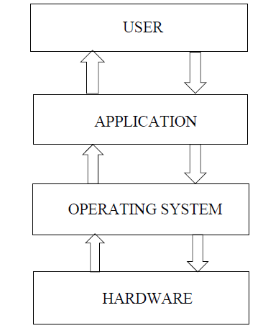
Figure 1.2 Embedded Block diagram
Every embedded system consists of custom-built hardware around a central processing unit (CPU). This hardware also contains memory chips onto which the software is loaded. The software residing on the memory chip is also called the "firm ware". The operating system runs above the hardware, and the application software runs above the operating system as shown in figure. The same architecture is applicable to any computer including a desktop computer.
However, there are significant differences. It is not compulsory to have an operating system in every embedded system. For small appliances such as remote-control units, air conditioners, toys etc., there is no need for an operating system and you can write only the software specific to that application. For applications involving complex processing, it is advisable to have an operating system.
We utilize it to go to our work place, remain in contact with our friends and family, and pass on our stock. Regardless, it can moreover pass on disaster to us and even can kill us through accidents. Speed is a champion among the most key and basic peril factors in driving. It impacts the reality of a crash, and also fabricates peril of being required in a crash. Regardless of various attempts taken by different authoritative and non-managerial affiliations all around the world by various ventures to careful against impulsive driving, yet disasters are happening every once in a while. In any case, many lives could have been saved if the emergency organization could get the crash information in time. Everything considered, capable customized incident acknowledgment with a modified cautioning to the emergency advantage with the setback zone is a prime need to save the profitable human life. It can moreover pass on disaster to us and even can kill us through accidents
In such a case, you need to integrate the application software with the operating system and then transfer the entire software on to the memory chip.
Figure 1.3: Interfacing Components in an Embedded system
As shown in above figure, the building blocks of an embedded system are:
- Central Processing Unit (CPU)
- Memory (RAM and ROM)
- Input devices
- Output devices
Central Processing Unit:
The Central Processing Unit may be a microcontroller, microprocessor or a Digital Signal Processor. A microcontroller is a low-cost processor. On the microcontroller chip itself, there will be many other components such as memory, serial communication interface, A/D converter etc. So, for small applications, a microcontroller is the best choice as the number of external components required will be very less. On the other hand,microprocessors are more powerful, but many external components are needed for them. Digital Signal Processors are mainly used for applications in which signal processing is involved such as audio and video processing.
Memory:
The memory is categorized as Random-Access Memory (RAM) and Read Only Memory (ROM). The contents of the RAM will be erased if power is switched off to the chip, whereas ROM retains the contents even if the power is switched off. So, the firmware is stored in the ROM. When power is switched on, the processor reads the ROM.
Input Devices:
The input devices to an embedded system have very limited capability. There will be no keyboard or a mouse, like in computers and hence interacting with the embedded system is no easy task. Many embedded systems used in process control do not have any input device for user interaction. They take inputs from sensors or transducers that will produce electrical signals that are fed to other systems.
Output Devices:
The output devices of the embedded systems also have very limited capability. Some embedded systems will have a few LEDs to indicate the health status of the system modules, or for visual indication of alarms. LCDs may also be used to display some important parameters.
APPLICATIONS OF EMBEDDED SYSTEMS
Embedded systems have vast applications in number of fields. The embedded system market is one of the highest growth areas as these systems are used in
- Consumer electronics
- Office automation
- Bio-Medical engineering
- Wireless communication
- Data communication
- Military
- Automobiles
- Aerospace
- Household Appliances
CHARACTERISTICS
All Embedded Systems are task specific. They do the same task repeatedly /continuously over their lifetime. An mp3 player will function only as an mp3 player. Embedded systems are created to perform the task within a certain time frame. It must therefore perform fast enough. A car’s brake system, if exceeds the time limit, may cause accidents. They have minimal or no user interface (UI). A fully automatic washing machine works on its own after the program is set and stops once the task is over. Some embedded systems are designed to react to external stimuli and react accordingly. A thermometer, a GPS tracking device. Embedded systems are built to achieve certain efficiency levels. They are small sized, can work with less power and are not too expensive. Embedded systems cannot be changed or upgraded by the users. Hence, they must rank high on reliability and stability. They are expected to function for long durations without the user experiencing any difficulties.
Microcontroller or microprocessors are used to design embedded systems. Embedded systems need connected peripherals to attach input & output devices. The hardware of an embedded-system is used for security and performance. The Software is used for features.

CHAPTER 2
LITERATURE SURVEY
2.1 INTRODUCTION
The development of intelligent automation systems has created a strong research interest in integrating human-centered input with machine control. In recent years, facial emotion recognition, smart home automation, embedded system design, and artificial intelligence-based decision-making have become important research domains. The proposed project, Emotion-Based Load Fan Speed Control Using Facial Expression Recognition, lies at the intersection of these areas. Therefore, a detailed literature survey is essential to understand the progress made in related fields, the techniques commonly used, the limitations of existing studies, and the research gap addressed by the present work.
Facial emotion recognition is one of the most active branches of affective computing. It focuses on identifying human emotions from facial expressions using image processing, machine learning, and deep learning methods. Since the human face provides rich visual cues about emotional states, many researchers have proposed systems that use cameras and algorithms to classify emotions such as happiness, sadness, anger, surprise, fear, disgust, and neutrality. With advances in deep learning, facial emotion recognition has become more accurate and practical for real-time applications.
At the same time, smart home automation has evolved from simple switch-based and remote-controlled systems to intelligent environments that can adapt to user behavior, preferences, and context. Recent studies have explored the use of IoT platforms, microcontrollers, sensors, wireless communication, and AI-based control strategies for developing low-cost and efficient home automation systems. These technologies have improved user convenience, energy efficiency, and interactive control.
Another important field related to the proposed work is embedded control using platforms such as Arduino, Raspberry Pi, and other microcontroller-based systems. These platforms are widely used in academic and prototype-level automation projects because they are cost-effective, flexible, and easy to interface with sensors and actuators. When combined with computer vision-based emotion recognition, embedded systems can execute real-world control actions such as adjusting fan speed, switching appliances, or indicating system status.
The literature reviewed in this chapter includes recent and relevant studies in facial emotion recognition, real-time camera-based emotion analysis, smart home automation, TinyML and lightweight emotion recognition, AI-IoT integration, and human-centered control systems. The review also includes studies that, while not directly implementing emotion-based fan control, provide the theoretical and practical foundation for building such a system. These works help in identifying existing approaches, understanding hardware-software integration, and analyzing the applicability of facial emotion recognition in smart automation.
This chapter is organized by discussing individual research works relevant to the proposed system. Each study is presented with its objectives, methodology, key findings, and relevance to the current project. The chapter concludes with a comparative discussion and the identification of the research gap that motivates the proposed work.

2.2 REVIEW OF LITERATURE
2.2.1 Hadjar, H., et al., “TheraSense: Deep Learning for Facial Emotion Analysis in Teleconsultation,” Electronics, vol. 14, no. 3, 2025
Hadjar et al. proposed a deep learning-based system named TheraSense for facial emotion analysis in teleconsultation environments. The authors recognized that emotional understanding plays an important role in virtual healthcare interactions, where direct observation by clinicians may be limited. In teleconsultation scenarios, patients communicate through cameras and video conferencing systems, making facial expression analysis a valuable tool for understanding mental and emotional states. The researchers aimed to design a system capable of analyzing facial emotions in real time using camera input and deep learning models.
The methodology of the work focused on acquiring facial images from camera-based teleconsultation sessions and processing them with deep learning techniques. The proposed framework used facial detection and feature extraction steps followed by emotion classification. The system was trained to recognize emotional expressions under practical video conditions and was evaluated for its performance in virtual consultation settings. The study showed that deep learning methods can provide meaningful emotion-related information even when applied in remote communication environments where lighting, camera angle, and image quality may vary.
The significance of this study lies in its demonstration of real-time facial emotion recognition using visual input from standard cameras. The work is highly relevant to the proposed emotion-based fan control project because it confirms that facial emotions can be analyzed in practical, non-laboratory environments using deep learning methods. In the current thesis, a camera is also used to capture the user’s face, and the emotion result is used for control action. Therefore, the TheraSense study supports the feasibility of using camera-based emotion recognition as the primary input for intelligent system control.
Another important contribution of this paper is that it highlights the need for reliable real-time performance. For any emotion-aware appliance control system, it is essential that the recognized emotion be processed quickly enough to trigger an immediate response. The present project benefits from this insight by considering a real-time pipeline where captured facial images are analyzed in the backend and converted into direct hardware control outputs. Thus, the work of Hadjar et al. provides a strong foundation in the area of practical deep learning-based facial emotion analysis.

2.2.2 Bai, M., et al., “Lightweight Emotion Analysis Solution Using Tiny Machine Learning,” Computers & Electrical Engineering, 2025
Bai et al. addressed an important limitation in conventional emotion recognition systems, namely their high computational complexity and large memory requirements. Many state-of-the-art deep learning models achieve good performance in facial emotion recognition, but they often require significant processing power, storage capacity, and energy consumption. These requirements make them unsuitable for portable, embedded, or low-resource devices. To solve this issue, the authors proposed a Tiny Machine Learning (TinyML) based emotion analysis solution designed specifically for lightweight and resource-constrained platforms.
The proposed system focused on reducing model size and computational cost while maintaining useful recognition capability. The authors designed a compact deep learning model with a significantly smaller number of parameters compared to traditional approaches. The model was optimized for deployment on portable devices, making it suitable for real-time edge applications. By reducing the memory footprint and computational overhead, the work demonstrated that facial emotion recognition can be brought closer to hardware platforms that operate without the need for high-end computing resources.
This research is particularly relevant to the proposed emotion-based fan speed control system because it highlights the possibility of implementing emotion recognition in compact or embedded setups. Although the current project uses a laptop or computer running Python for backend processing, future versions of the system may require direct deployment on edge devices. The work of Bai et al. shows that lightweight models can enable such portability and efficiency. It provides useful insight for reducing system complexity and making emotion-aware automation more practical for real-world smart home applications.
Another important aspect of this paper is its contribution to energy-efficient intelligent systems. Since the proposed project also aims to create a user-friendly and practical automation model, using lightweight recognition methods can improve responsiveness and reduce processing load. The study of Bai et al. therefore supports the direction of building simpler and more efficient emotion detection modules for intelligent appliance control.

2.2.3 Sone, Y., et al., “Development of a Control Support System for Smart Homes,” Robomech Journal, 2025
Sone et al. proposed a control support system for smart homes aimed at improving the interaction between users and home devices. The study recognized that although smart homes offer automation and convenience, many existing systems still lack personalized adaptation and intuitive response. Users often need to configure devices manually or rely on predefined automation rules that may not reflect their current needs, interests, or comfort preferences. The authors sought to create a system capable of supporting control decisions based on the analysis of user-related information.
The system developed in the study focused on improving home device control by interpreting user interests and integrating intelligent support mechanisms. The authors emphasized that smart homes should move beyond static automation and become more responsive to the user’s condition and behavior. Their work explored ways to enhance interaction between the user and home environment by allowing the control system to act more intelligently and contextually.
This study is highly relevant to the proposed emotion-based fan speed control system because it supports the concept of human-centered smart home automation. In the present project, the fan is not controlled merely by temperature or manual input; instead, it responds to the user’s emotional state. This aligns with the broader smart home principle described by Sone et al., where appliance control is adapted to user-specific factors. The study provides conceptual support for developing systems that take human-related input as a basis for control actions.
The work also emphasizes the importance of user comfort and intelligent response in domestic environments. This is directly related to the objective of the proposed thesis, which seeks to improve comfort through automatic fan speed control based on detected emotion. While Sone et al. did not focus specifically on facial emotion recognition, their smart home control support framework reinforces the need for personalized automation and validates the importance of the proposed approach.

2.2.4 Addow, M. A., et al., “A Low-Cost IoT-Based Smart Home Automation System for Urban Environments,” Discover Internet of Things, 2025
Addow et al. presented a low-cost IoT-based smart home automation system designed for urban environments. The authors observed that many commercial smart home systems are expensive and not easily accessible to a wide range of users, especially in cost-sensitive settings. To address this issue, the researchers proposed an affordable automation model that uses IoT technology to enable efficient appliance monitoring and control. Their work focused on creating a system that is practical, scalable, and suitable for real-life implementation.
The methodology of the paper involved the design of an IoT-enabled home automation architecture using cost-effective electronic components, communication protocols, and control interfaces. The system allowed appliances to be monitored and controlled remotely, improving user convenience and enabling centralized management. The researchers emphasized affordability and practicality as key goals, showing that useful automation solutions can be developed without relying on expensive proprietary platforms.
This research is important for the proposed thesis because it provides a strong background in low-cost smart home automation, which is a major theme of the current project. The emotion-based fan speed control system also aims to be affordable and practical by using commonly available components such as Arduino Uno, camera, motor driver, LCD display, and LEDs. The work of Addow et al. supports the idea that meaningful automation can be achieved with cost-effective hardware and well-designed control logic.
Although their study does not include emotion recognition, it establishes the practical relevance of appliance automation in modern homes and demonstrates how low-cost systems can enhance daily living. The present thesis extends this concept further by integrating emotional intelligence into the control process. Thus, Addow et al. provide useful literature support regarding system affordability, appliance control, and the feasibility of prototype-level smart home implementation.

2.2.5 Aleran, A., et al., “Artificial Intelligence and the Internet of Things in Energy Preservation: Research Prototypes, Trends, and Future Directions,” Computing, 2025
Aleran et al. explored the integration of artificial intelligence and the Internet of Things for energy preservation in smart environments. The authors recognized that energy efficiency has become a major concern in intelligent systems, especially as homes, offices, and urban spaces are increasingly filled with connected devices. Traditional automation systems often follow fixed rules and may not optimize energy usage effectively. Therefore, the study reviewed and analyzed research prototypes that combine AI and IoT to improve intelligent control and energy management.
The paper discussed current trends in AI-IoT systems, highlighting how machine intelligence can be used to make more adaptive and efficient decisions. The authors examined different prototype designs that use sensors, connected devices, predictive control, and context-aware algorithms to reduce energy wastage and improve automation quality. The study also pointed out future directions for developing smarter and more sustainable intelligent systems.
This work is relevant to the proposed emotion-based fan control system because it emphasizes the value of adaptive intelligent control in reducing unnecessary appliance operation. In the current project, the fan is turned OFF when a happy emotion is detected, which can help avoid unnecessary power consumption. By mapping emotions to different fan responses, the system introduces a form of context-based control. The work of Aleran et al. supports this broader principle that intelligent automation can improve both user experience and resource efficiency.
The study also provides a conceptual basis for integrating AI into household automation. In the proposed thesis, Python-based emotion recognition serves as the AI component, while Arduino-based hardware control acts as the appliance interface. This combination reflects the kind of intelligent automation approach discussed by Aleran et al. Therefore, the paper offers useful insight into how AI-enhanced decision-making can make appliance control more efficient and adaptive.

2.2.6 Sarvakar, K., et al., “Revolutionizing Facial Emotion Recognition: In-Depth Analysis and Recent Advances,” Discover Artificial Intelligence, 2025
Sarvakar et al. presented an in-depth analysis of recent advances in facial emotion recognition. The study reviewed major techniques, developments, and challenges in the field, with particular attention to the role of machine learning and deep learning in improving recognition performance. The authors discussed how facial emotion recognition has evolved from traditional handcrafted feature methods to modern data-driven architectures capable of learning highly discriminative facial patterns.
The paper examined several important aspects of facial emotion recognition, including face detection, feature extraction, classification methods, datasets, and performance evaluation. It also addressed practical challenges such as occlusion, pose variation, lighting changes, cultural differences, and expression ambiguity. The study emphasized that although deep learning has significantly improved recognition accuracy, real-world implementation still requires careful attention to robustness and generalization.
This literature is highly valuable to the proposed work because it provides a broad understanding of the technical background behind facial emotion recognition. Since the thesis relies on camera-based emotional analysis as the main input for fan control, knowledge of current advancements and limitations in this field is essential. The review by Sarvakar et al. helps justify the choice of facial emotion recognition as a viable and actively developing research area.
In addition, the paper strengthens the academic foundation of the current project by showing that emotion recognition is not limited to theoretical studies but is increasingly applied in practical systems. The proposed fan speed control model represents one such applied use case. Thus, this review article serves as an important reference for understanding the current state of the art and the challenges that must be considered in emotion-aware automation.

2.2.7 Almeida, C., et al., “Dainattor: A Web System for Real-Time Facial Expression Recognition,” Journal of Artificial Intelligence and Technology, 2025
Almeida et al. introduced a real-time facial expression recognition system named Dainattor, designed as a web-based platform. The study highlighted the growing demand for systems that can detect emotions in real time and provide immediate feedback or adaptation. The proposed platform used facial expression analysis techniques to identify emotional states from live visual input and make the results available through an interactive system.
The methodology emphasized the importance of real-time processing and user accessibility. By designing the emotion recognition system as a web platform, the authors aimed to make the technology more usable and widely deployable. The system demonstrated that facial emotion recognition can be implemented in practical software environments and integrated into interactive applications that respond dynamically to user expressions.
This study is relevant to the proposed fan speed control system because it reinforces the importance of real-time emotion recognition in applied settings. In the thesis project, the success of the system depends on the timely detection of facial emotion and immediate control of the fan. The work of Almeida et al. supports the idea that fast and interactive emotion recognition is both feasible and useful in user-facing systems.
Furthermore, the study suggests that emotion recognition can be integrated into accessible application environments, not just isolated research experiments. This encourages the broader applicability of the proposed thesis work, where the backend emotion detection may be enhanced or extended in future into more advanced software or networked platforms. Therefore, the Dainattor system contributes valuable insight into practical real-time emotion recognition.

2.2.8 Chutia, T., et al., “A Review on Emotion Detection by Using Deep Learning,” Artificial Intelligence Review, 2024
Chutia et al. provided a comprehensive review of emotion detection using deep learning techniques. The authors discussed the role of deep learning in extracting complex and meaningful patterns from emotional data, especially in facial images, speech, text, and multimodal inputs. The paper examined the advantages of deep neural architectures in improving detection accuracy compared to traditional machine learning methods.
In the context of facial emotion recognition, the review highlighted the widespread use of convolutional neural networks, transfer learning, and hybrid deep learning models. It also discussed benchmark datasets, performance metrics, training challenges, and application areas. The study emphasized that deep learning has become the dominant approach in modern emotion detection research because of its ability to automatically learn relevant features from data.
This review is useful for the proposed thesis because it gives a strong theoretical and technical foundation for the use of Python-based emotion detection. Although the project may use a practical implementation tailored for prototype development, the underlying concept of facial emotion recognition is closely linked to the deep learning approaches discussed by Chutia et al. The paper supports the academic validity of using AI-based methods for recognizing emotions from facial images.
The study also helps in understanding current trends and research directions in emotion detection, which is useful for discussing the broader significance and future scope of the thesis. By linking the project to a wider body of deep learning research, the literature strengthens the justification for the proposed system and demonstrates that emotion-aware automation has strong support from recent AI developments.

2.2.9 Mathe, S. E., et al., “A Comprehensive Review on Applications of Raspberry Pi,” Renewable and Sustainable Energy Reviews, 2024
Mathe et al. presented a comprehensive review of Raspberry Pi applications across different engineering and technological domains. The study examined the use of Raspberry Pi as an embedded platform in automation, robotics, IoT, monitoring systems, and educational projects. The authors highlighted the advantages of compact computing boards for implementing low-cost intelligent systems that combine sensing, processing, and communication.
Although the paper focused on Raspberry Pi rather than Arduino, it is relevant to the proposed project because it discusses the importance of compact embedded platforms in real-time control and smart system development. The review showed that such devices are increasingly used for integrating computer vision, data processing, and hardware interfacing in a single framework. This is especially significant for projects that involve automation and edge intelligence.
For the current thesis, the work of Mathe et al. suggests possible future extensions where facial emotion recognition and fan control can be implemented on a single compact platform instead of using separate laptop and microcontroller modules. While the present project uses a computer for backend processing and Arduino for control, Raspberry Pi-like systems may support tighter integration in future designs. The paper therefore contributes to the understanding of embedded platform options for smart appliance control.

2.2.10 Rizzardi, A., et al., “Towards Rapid Modeling and Prototyping of Indoor and Outdoor IoT Applications,” Sustainable Futures, 2024
Rizzardi et al. discussed methods for rapid modeling and prototyping of IoT applications for indoor and outdoor environments. The authors emphasized the importance of fast, flexible, and scalable development approaches in the design of IoT systems. Their work focused on enabling developers and researchers to create prototypes more efficiently, reducing the complexity involved in integrating sensors, communication modules, software interfaces, and application logic.
The paper is relevant to the proposed thesis because the developed emotion-based fan control system is also a prototype that integrates multiple subsystems, including camera input, Python-based processing, microcontroller control, and hardware outputs. The work of Rizzardi et al. supports the importance of prototype-driven development in automation research and encourages modular design principles that simplify system integration.
Another useful aspect of the paper is its emphasis on practical deployment and experimentation. For academic projects such as the present one, rapid prototyping allows researchers to validate concepts before scaling them to real-world systems. The proposed project follows a similar philosophy by implementing a proof-of-concept model for emotion-aware fan control. Thus, this literature provides methodological relevance in terms of system development approach and experimental prototyping.

2.3 COMPARATIVE ANALYSIS OF REVIEWED LITERATURE
The reviewed literature reveals that significant progress has been made in the areas of facial emotion recognition, smart home automation, lightweight AI implementation, and intelligent control systems. Studies such as those by Hadjar et al., Almeida et al., and Chutia et al. show that camera-based facial emotion recognition using deep learning is becoming increasingly practical and accurate. These works confirm that emotions can be detected in real time from facial expressions and used for interactive applications.
On the other hand, studies by Sone et al., Addow et al., and Aleran et al. highlight the broader context of smart home automation and adaptive control. These works show that home appliances can be made more intelligent through AI, IoT, and user-centered design. However, most of these systems focus on user behavior, remote control, environmental sensing, or energy optimization rather than direct facial emotion input.
The study by Bai et al. contributes an important perspective by showing that emotion recognition can also be implemented in lightweight and resource-constrained devices. This supports the future possibility of integrating recognition and control more compactly. Similarly, embedded platform and prototyping studies indicate that low-cost hardware can be effectively used for smart automation experiments and practical implementations.
Overall, the literature suggests that the technologies required for the proposed system already exist in related forms. Real-time facial emotion recognition is feasible, low-cost smart home automation is practical, and embedded hardware control is widely supported. However, the combination of these elements into a dedicated emotion-based fan speed control system using facial expression recognition is still limited in the reviewed studies. This creates a clear research opportunity for the present work.

2.4 RESEARCH GAP
From the reviewed literature, it is evident that many researchers have worked separately on facial emotion recognition, smart home automation, AI-IoT systems, and embedded appliance control. However, only a limited number of studies directly connect real-time facial emotion detection with the control of a household load such as a fan. Most existing systems either focus on emotion analysis for healthcare, communication, or web interaction, or they focus on appliance automation using temperature, motion, IoT commands, or predefined user preferences.
There is therefore a gap in the development of a simple, low-cost, emotion-aware appliance control prototype that uses facial expressions as the direct control input. Specifically, limited work has been reported on systems where a camera captures the user’s face, Python detects emotional state in real time, and an Arduino-based controller adjusts fan speed and status indicators accordingly. The proposed thesis addresses this gap by integrating these components into a single practical automation system.
Another gap lies in the application-oriented demonstration of emotion-aware control using accessible hardware and straightforward mapping of emotions to real-world outputs. Many advanced studies remain software-focused or computationally complex, making them less suitable for educational prototypes and low-cost smart home experiments. The present work contributes by providing a clear and implementable model that links AI-based facial emotion recognition with physical appliance control.

2.5 RELEVANCE OF LITERATURE TO THE PROPOSED WORK
The reviewed literature collectively supports the design and implementation of the proposed emotion-based load fan speed control system. The facial emotion recognition studies provide the theoretical and algorithmic basis for identifying human emotions from camera input. The smart home and IoT automation papers establish the practical importance of intelligent appliance control in modern living environments. The embedded system and TinyML studies contribute knowledge about efficient implementation and low-cost hardware integration.
Each reviewed paper contributes a different perspective. Some validate the feasibility of real-time emotion detection, while others reinforce the value of adaptive appliance control and AI-driven automation. Together, they justify the present research and show that the proposed system is built upon strong and relevant technological foundations. At the same time, the identified research gap shows that the current project adds novelty by combining these domains into a single targeted application for fan speed control.

2.6 CHAPTER SUMMARY
This chapter presented a detailed literature survey related to the proposed thesis on emotion-based load fan speed control using facial expression recognition. The review covered recent studies in deep learning-based facial emotion recognition, real-time emotion analysis, lightweight emotion recognition models, smart home control support systems, low-cost IoT automation, AI-IoT energy preservation, and embedded system applications. Each work was discussed in terms of its objective, methodology, contribution, and relevance to the proposed project.
The survey revealed that while substantial progress has been made in the individual areas of emotion recognition and intelligent automation, limited work has been carried out in combining these technologies for direct fan speed control based on facial emotion. This identified gap provides the motivation for the present thesis. The chapter therefore establishes the research foundation for the proposed system and leads naturally to the discussion of the existing system and proposed methodology in the following chapters

.
.
.

CHAPTER 3
EXISTING METHOD

3.1 INTRODUCTION
In recent years, automation systems have been widely used to improve convenience, reduce manual effort, and enhance the performance of household and industrial appliances. Among different appliances, the electric fan remains one of the most common devices used for maintaining a comfortable indoor environment. Traditionally, fan operation is controlled manually using regulators, switches, or remote-based systems. Later, more advanced control methods were introduced using sensors such as temperature sensors, humidity sensors, motion detectors, and timer circuits. These methods brought a degree of automation, but they still primarily focus on environmental conditions or preset user commands rather than the emotional condition of the user.
The proposed thesis focuses on controlling fan speed based on facial emotion recognition. Before presenting the proposed method, it is necessary to study the existing methods and understand their working principles, advantages, and limitations. The existing methods in this context mainly include manual fan control systems, sensor-based automatic fan control systems, IoT-based appliance control systems, and general smart home automation systems without emotion recognition. These methods provide a useful foundation for understanding how fan control has evolved and why a more intelligent, emotion-aware approach is needed.
This chapter discusses the existing methods that are commonly used for fan and appliance control. It highlights their system structure, operation, and drawbacks. The chapter also explains why these methods are insufficient for providing personalized and emotionally responsive comfort, thereby justifying the need for the proposed emotion-based fan speed control system.
3.2 CONVENTIONAL MANUAL FAN CONTROL SYSTEM
The most basic and widely used existing method for controlling a fan is the manual control system. In this method, the fan is operated using mechanical switches, regulators, or electronic speed controllers. The user directly selects the desired fan speed based on personal comfort. In a typical household setup, the fan may have multiple speed levels, and the user adjusts the regulator manually whenever there is a need to increase or decrease airflow.
The manual control method is simple, low-cost, and easy to implement. It does not require any sensors, complex circuitry, or software programming. Because of its simplicity, it has been used extensively in homes, offices, classrooms, and public spaces for many years. The system is reliable in basic operation, and the user has full control over the fan at all times.
However, the manual method has several limitations. The main disadvantage is that it requires continuous user intervention. Whenever the user feels uncomfortable, the fan speed must be adjusted manually. This becomes inconvenient, especially when the user’s comfort level changes frequently. Moreover, the system has no intelligence or awareness of the user’s physical or emotional condition. It cannot respond automatically to changes in the surrounding environment or the state of the user. As a result, manual control systems are not suitable for modern smart automation applications where convenience, adaptability, and personalization are expected.
3.3 TEMPERATURE-BASED AUTOMATIC FAN CONTROL SYSTEM
One of the commonly used improvements over manual fan operation is the temperature-based automatic fan control system. In this method, a temperature sensor is used to monitor ambient temperature, and the fan speed is adjusted automatically according to the measured value. The system may use analog circuits, microcontrollers, or digital control units to compare the sensed temperature with predefined threshold values. Based on the result, the controller increases, decreases, or switches the fan speed.
This method offers a significant advantage over manual control because it eliminates the need for constant user adjustment. The fan reacts automatically to changes in environmental temperature, which makes the system more convenient and energy-efficient in certain conditions. Temperature-based control is commonly used in cooling systems, desktop computers, industrial equipment, and some household automation applications.
Despite these advantages, the temperature-based control system has several limitations when viewed from a human-centered perspective. The system only responds to ambient temperature and does not consider the actual comfort preference or emotional state of the user. Two users in the same room may experience different comfort levels even if the temperature is constant. For example, a person who is angry or stressed may prefer stronger airflow, while another person in a relaxed mood may not need much cooling. A temperature-based system cannot recognize such differences. Therefore, although it provides automatic control, it lacks personalization and emotional adaptability.
Another drawback is that temperature sensors may sometimes respond slowly to sudden changes in the environment, and the selected threshold values may not match the user’s real-time needs. This can reduce the effectiveness of the system in providing accurate comfort control. Thus, temperature-based fan automation is still limited in delivering intelligent and user-specific responses.
3.4 HUMIDITY- AND ENVIRONMENT-BASED FAN CONTROL
In addition to temperature-based control, some existing systems use humidity sensors or a combination of environmental sensors to regulate fan operation. These systems monitor parameters such as air humidity, room temperature, air quality, or motion presence and then adjust fan speed or switching behavior accordingly. Such systems are more advanced than simple manual control because they consider environmental conditions in a broader manner.
Environmental sensor-based systems are often used in smart ventilation, bathroom exhaust fans, greenhouses, and automated indoor comfort systems. For example, if humidity rises above a threshold, the fan may be activated to improve ventilation. In some cases, a combination of temperature and humidity readings is used to control airflow more effectively. When integrated with microcontrollers, such systems can provide automatic operation without direct user intervention.
However, these systems still suffer from a major limitation: they are environment-centered rather than human-centered. They measure only physical parameters of the surroundings and do not account for the emotional or psychological state of the user. Even if the room environment is within normal limits, the user may still feel discomfort due to emotional stress, sadness, or irritation. Environmental sensor-based systems cannot understand these internal human factors. Therefore, although these methods improve automation, they remain insufficient for creating a truly personalized and emotion-aware control mechanism.
3.5 TIMER-BASED AND PREDEFINED FAN CONTROL SYSTEMS
Another category of existing methods includes timer-based fan control and predefined programmable control systems. In timer-based systems, the fan is switched ON, OFF, or operated at certain speeds for a preset time duration. These methods are commonly used for convenience and energy saving, especially in homes and offices where users may want the fan to operate only during specific hours or for a limited time.
Predefined fan control methods may also include programmable logic where fixed rules determine the fan’s operation. For example, the fan may run at low speed during the night and high speed during the daytime, or it may follow a sequence determined by a controller program. These methods improve automation to some extent by reducing the need for repeated manual switching.
The disadvantage of timer-based and predefined control is that they are rigid and non-adaptive. They do not respond to real-time user needs or changes in emotional condition. If the user’s comfort level changes unexpectedly, the preset timing or sequence may no longer be appropriate. Such systems are useful only in predictable scenarios and cannot provide the flexibility required for intelligent human-centered automation. Therefore, these approaches are limited in applications where real-time adaptation is essential.

3.6 REMOTE-CONTROLLED AND IOT-BASED FAN CONTROL SYSTEMS
With the advancement of communication technology, many modern fan control systems have adopted remote control and IoT-based methods. In remote-controlled systems, the user operates the fan using an infrared remote or wireless device. In IoT-based systems, the fan is connected to a network and can be controlled through a mobile app, web interface, or cloud platform. These systems provide greater convenience and allow users to operate appliances from a distance.
IoT-based fan control systems are particularly useful in smart homes and building automation. They can support scheduling, remote access, energy monitoring, and integration with other smart devices. Some systems also use voice assistants or smartphone applications to make control easier. This level of connectivity marks an important improvement over traditional methods and reflects the trend toward intelligent homes.
However, remote-controlled and IoT-based systems are still dependent on explicit user commands. Although they improve accessibility and convenience, they do not automatically understand the user’s emotional state. The user must still provide input through a remote, phone, or application. As a result, the system is not fully autonomous in a human-centered sense. It assists the user but does not interpret facial expressions or emotional conditions to make decisions on its own.
Another limitation of IoT-based systems is the added complexity and dependence on communication infrastructure. Network latency, connectivity issues, and security concerns may affect performance. For a simple real-time comfort application such as fan control, relying entirely on remote network control may not always be efficient. Thus, while IoT-based methods represent an advanced stage of automation, they still fall short of true emotion-aware control.
3.7 SENSOR-BASED OCCUPANCY AND MOTION-CONTROLLED FAN SYSTEMS
Some existing fan control systems use occupancy sensors or motion detectors to automate switching behavior. These systems detect whether a person is present in the room and turn the fan ON or OFF accordingly. They are commonly used for energy saving in offices, meeting rooms, public spaces, and smart buildings. If no movement is detected for a certain period, the system may turn the fan OFF to save power.
Occupancy-based control is useful because it reduces unnecessary fan operation and improves energy efficiency. It is also more convenient than purely manual systems because the user does not have to remember to switch the fan ON or OFF. In many applications, this kind of control is effective and practical.
Despite its usefulness, occupancy-based control is still limited. The system only detects the presence or absence of a person, not the person’s actual comfort requirement or emotional condition. Once a person is detected, the fan may operate in a predefined way regardless of whether the user feels hot, calm, sad, or angry. Thus, the system lacks the ability to personalize airflow intensity based on internal human factors. It can automate appliance usage, but it cannot make emotionally informed decisions.
3.8 EXISTING FACIAL EMOTION RECOGNITION SYSTEMS
Apart from appliance control, a separate line of existing systems has been developed for facial emotion recognition. These systems use cameras, image processing, and machine learning or deep learning algorithms to identify human emotions from facial expressions. Their applications include healthcare monitoring, online learning, driver alertness assessment, customer feedback analysis, entertainment, and security systems. Emotions commonly recognized include happiness, sadness, anger, surprise, fear, disgust, and neutrality.
In a typical facial emotion recognition system, a camera captures the face image, a face detection algorithm locates the facial region, and a classifier analyzes expression-related features to determine the emotion. Modern systems often use convolutional neural networks or transfer learning methods to achieve better performance. These systems show that computers can interpret facial expressions effectively and provide real-time emotional analysis.
Although facial emotion recognition systems are highly relevant to the proposed project, most existing works remain limited to analysis, monitoring, or feedback applications. They do not usually connect the recognized emotion directly with hardware actuation for household appliance control. In other words, the output is often displayed on a screen, stored in a database, or used for software interaction rather than being translated into physical control actions such as fan speed adjustment. This reveals a gap between emotion recognition research and practical appliance automation, which the present thesis aims to address.
3.9 SMART HOME AUTOMATION WITHOUT EMOTION RECOGNITION
Many smart home systems available today rely on a combination of sensors, user preferences, remote interfaces, and programmed logic to control appliances. These systems can automate lights, fans, air conditioners, security devices, and entertainment systems. They may use IoT, cloud computing, mobile apps, and voice assistants to improve convenience and centralize control.
Such systems are helpful in reducing human effort and enhancing efficiency. They also support advanced functions such as scheduling, remote diagnostics, and energy monitoring. However, most smart home automation platforms are built around environmental sensing, occupancy detection, or direct user commands. They are not designed to understand facial expressions or emotional states.
This lack of emotional awareness is a major limitation in human-centered smart homes. A home that is technically smart may still fail to provide truly personalized comfort if it cannot interpret non-verbal human cues. The proposed system attempts to move beyond this limitation by introducing emotion recognition as a direct input for appliance control. In this sense, the current work can be seen as an extension of existing smart home automation toward affective and adaptive control.
3.10 BLOCK REPRESENTATION OF EXISTING METHOD
In a general existing automatic fan control system, the operation begins with either manual input or environmental sensor input. If it is a manual system, the user adjusts the regulator directly. If it is an automatic system, sensors such as temperature, humidity, or motion sensors send input to a controller. The controller processes the input and sends appropriate signals to the motor driver or relay unit. The fan then operates according to the received command.
The overall flow of such systems can be summarized as follows:
Input Source (User/Sensor) → Controller → Driver/Relay → Fan Output
This structure is simple and practical, but it lacks any module for emotion capture or facial analysis. There is no camera, no emotion recognition software, and no mapping between facial expression and control action. Therefore, the system is limited to environmental or manually supplied information.
3.11 WORKING PRINCIPLE OF EXISTING METHOD
The working principle of the existing method depends on the type of control system used. In manual systems, the user observes personal comfort and directly changes the fan speed using a regulator. In temperature-based systems, the temperature sensor measures the room condition and sends the value to a controller. The controller compares the reading with preset thresholds and adjusts the fan speed accordingly. In occupancy-based systems, a motion sensor detects presence and triggers fan operation.
In each case, the fan operates according to fixed rules derived from direct user commands or physical sensor data. The system does not have the ability to detect, interpret, or respond to facial emotions. It also does not provide differentiated responses based on emotional states such as anger, sadness, or happiness. Therefore, the operation remains limited to a basic form of automation.
3.12 ADVANTAGES OF EXISTING METHOD
The existing methods do offer several benefits, which explain their continued usage in homes and offices. Manual systems are simple, low-cost, and easy to maintain. Sensor-based systems improve convenience by automating control according to environmental conditions. IoT-based systems enable remote access and integration with smart devices. Occupancy-based systems help reduce unnecessary power usage.
These advantages make existing methods practical for general-purpose fan operation. They are suitable for situations where environmental comfort alone is sufficient or where advanced personalization is not required. Their hardware design is usually straightforward, and many of them can be implemented with low complexity.
3.13 LIMITATIONS OF EXISTING METHOD
Although existing methods are useful, they have several important limitations when viewed in the context of intelligent and human-centered automation.
The first limitation is the absence of emotion recognition. Existing systems cannot understand the user’s emotional state, even though emotions strongly influence comfort and preference. They respond only to external conditions or manual input.
The second limitation is the lack of personalization. Most methods use fixed thresholds or predefined logic. They assume that the same input should always produce the same fan response, regardless of who the user is or how the user feels at that moment.
The third limitation is the need for manual intervention in many systems. Even remote-controlled and app-based methods still depend on user commands. This reduces the level of true automation.
The fourth limitation is insufficient human-machine interaction. Existing systems do not create a natural interface based on facial cues. Instead, they rely on switches, remotes, sensors, or apps.
The fifth limitation is restricted adaptability. Real-life comfort is influenced by emotional and psychological factors in addition to environmental conditions. Existing systems do not incorporate such factors, making their responses less adaptive and less human-centered.
The sixth limitation is that facial emotion recognition and hardware control are usually not integrated in most available systems. Emotion recognition systems exist separately, and appliance automation systems exist separately, but the combination of the two is still limited.
3.14 NEED FOR IMPROVEMENT OVER EXISTING METHOD
The limitations of existing methods clearly indicate the need for a more advanced control strategy. A fan control system should ideally respond not only to physical environmental parameters but also to the condition of the user. Since facial expressions are strong indicators of emotion, integrating a camera-based emotion recognition module with appliance control can make the system more intelligent and personalized.
An improved system should be able to capture facial expressions in real time, analyze the emotional state, and translate that information into appropriate fan speed control. Such a system would reduce manual effort, enhance comfort, and provide a more interactive user experience. It would also represent a practical step toward the broader vision of emotion-aware smart homes and human-centered automation.
3.15 CHAPTER SUMMARY
This chapter discussed the existing methods used for fan and appliance control, including manual control systems, temperature-based automation, humidity-based control, timer-based methods, remote-controlled systems, IoT-based automation, occupancy-based systems, and standalone facial emotion recognition systems. It explained their working principles, benefits, and major limitations.
The analysis showed that existing fan control methods are generally based on manual input, environmental sensing, or remote commands. While these methods provide convenience and basic automation, they do not consider the emotional condition of the user. Similarly, facial emotion recognition systems are capable of analyzing emotional states, but in most cases they are not directly integrated with appliance control. This creates a gap that motivates the proposed system. The next chapter presents the proposed method for developing an emotion-based load fan speed control system using facial expression recognition.
.
.
.

CHAPTER 4
PROPOSED METHOD

4.1 INTRODUCTION
The proposed method of this thesis focuses on developing an intelligent fan speed control system that operates based on the facial emotion of the user. Unlike conventional fan control methods that depend on manual adjustment, temperature sensing, or timer-based operation, the proposed system introduces a human-centered control mechanism in which the emotional state of the user acts as the decision input. The system combines real-time facial image capture, Python-based emotion detection, Arduino-controlled hardware interfacing, and automated fan speed regulation to create a smart and interactive automation model.
The objective of the proposed method is to design a practical prototype that can detect specific emotions such as anger, sadness, and happiness through a camera and convert the detected emotional state into corresponding hardware actions. These hardware actions include controlling the speed of a DC fan, turning ON the appropriate LED indicator, and displaying the system status on an LCD screen. Through this approach, the proposed system not only demonstrates the use of facial emotion recognition in appliance control but also highlights the potential of combining artificial intelligence and embedded systems for smart home applications.
This chapter explains the complete methodology of the proposed system, including the system concept, block diagram explanation, hardware components, software architecture, operational flow, algorithm, and functional mapping between emotions and fan speed control. It also describes the integration of Python-based emotion recognition with Arduino-based hardware control and presents the overall working principle of the system.
4.2 OVERVIEW OF THE PROPOSED SYSTEM
The proposed system is an Emotion-Based Load Fan Speed Control System Using Facial Expression Recognition. It is designed to detect the facial emotion of a user in real time and automatically control the speed of a fan according to the identified emotion. The system uses a camera to capture the face, a Python program to recognize the emotion, and an Arduino Uno to execute the appropriate control action.
The overall concept of the system is based on the idea that emotional states can be used as intelligent control inputs for appliances. Human facial expressions provide visual clues about emotional conditions such as anger, happiness, and sadness. By detecting these expressions through image processing and machine learning techniques, the system can infer the user’s emotional state and respond automatically. This makes appliance control more personalized, interactive, and adaptive compared to conventional methods.
In the proposed model, three emotions are considered. When anger is detected, the red LED is turned ON and the fan is driven at high speed. When sadness is detected, the yellow LED glows and the fan runs at medium speed. When happiness is detected, the green LED is turned ON and the fan remains OFF. The LCD display is used to show the detected emotion and the corresponding fan status. The system therefore acts as a bridge between facial emotion recognition and physical device automation.
4.3 Design Objectives of the Proposed Method
The proposed method is designed with the following objectives:
- To capture the user’s face continuously using a camera.
- To analyze the captured facial image using Python-based emotion detection.
- To classify the emotion into anger, sadness, or happiness.
- To send the detected emotion result to an Arduino Uno through serial communication.
- To control the speed of a DC fan automatically based on the classified emotion.
- To provide LED-based visual indication for each detected emotion.
- To display the current emotion and fan status on the LCD screen.
- To develop a practical and low-cost prototype for emotion-aware automation.
These objectives ensure that the proposed system is both functionally effective and suitable for academic demonstration as well as future expansion.
4.4 SYSTEM ARCHITECTURE
The architecture of the proposed system consists of two major sections: the software section and the hardware control section.
The software section includes the camera and the Python-based facial emotion recognition module. The camera captures the user’s facial image in real time. The Python program processes the image, detects the face, extracts facial features, and classifies the emotion. Once the emotion is identified, the software sends a corresponding signal or label to the Arduino Uno through serial communication.
The hardware control section includes the Arduino Uno, motor driver, DC fan, LCD display, LEDs, and power supply. The Arduino receives the emotion information from the Python program and performs the required control action. The fan speed is adjusted using the motor driver, while LEDs and LCD provide status indication.
Thus, the proposed system integrates image acquisition, emotion recognition, microcontroller-based control, actuator interfacing, and output display into one complete framework.
4.5 BLOCK DIAGRAM OF THE PROPOSED SYSTEM
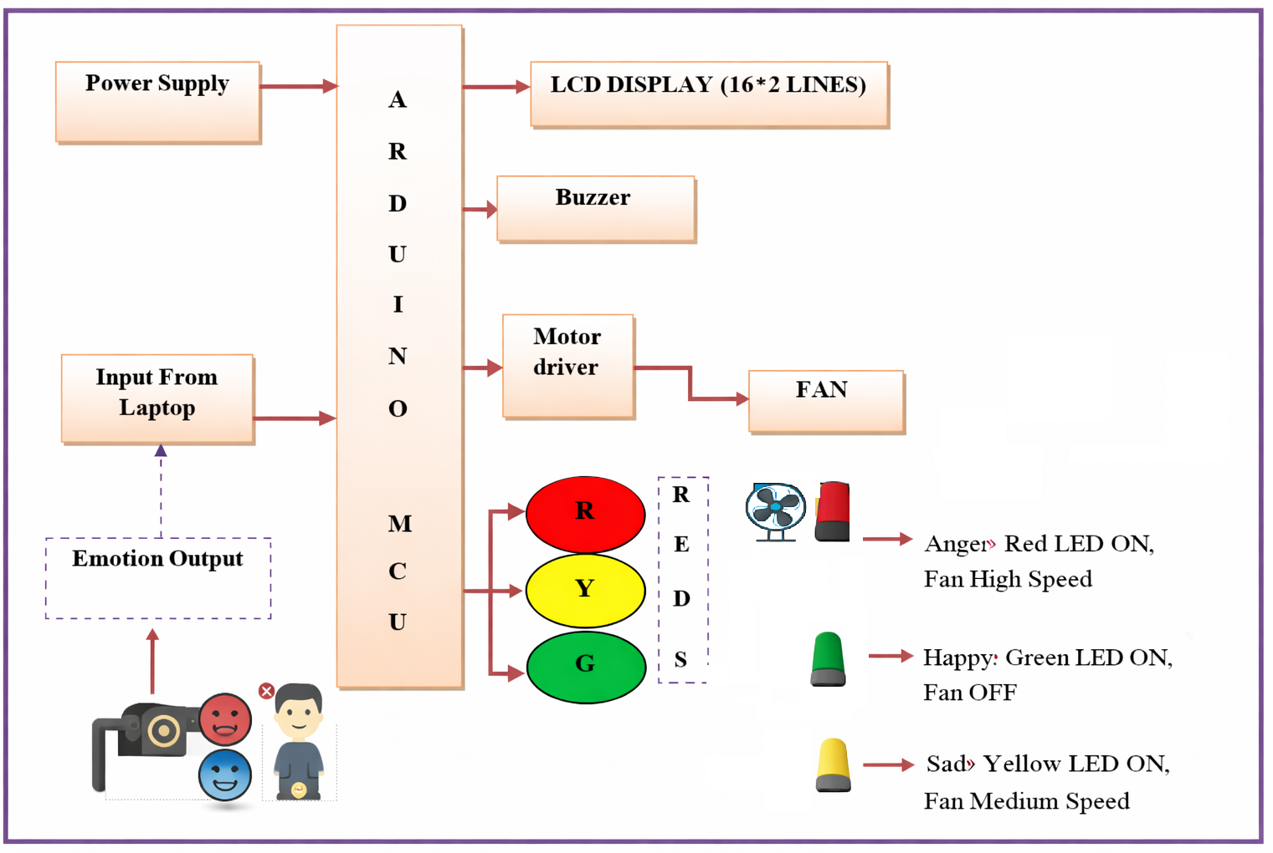
4.5.1 Explanation of Block Diagram
The power supply provides the electrical power required for the operation of the Arduino, motor driver, LEDs, LCD, and fan. A stable supply is essential for proper system operation.
The camera acts as the input device. It continuously captures the facial image of the user and sends the video stream to the laptop or computer.
The laptop/computer runs the Python-based facial emotion detection program. This program processes the camera feed, identifies the face, and classifies the facial expression into one of the selected emotions.
The Arduino Uno serves as the central hardware controller. It receives the detected emotion data from the computer and decides the corresponding hardware action to be taken.
The motor driver is used to drive the fan safely according to the signal received from the Arduino. Since the fan requires more current than the Arduino can directly supply, the motor driver acts as an interface between the controller and the fan.
The DC fan is the main output load. Its speed is controlled according to the detected emotion.
The LCD display shows the detected emotion and fan status, helping the user understand the operation of the system.
The LED indicators provide quick visual feedback. A red LED corresponds to anger, a yellow LED corresponds to sadness, and a green LED corresponds to happiness.
4.6 HARDWARE COMPONENTS OF THE PROPOSED SYSTEM
The proposed system uses the following hardware components:
4.6.1 Camera
The camera is used to capture the facial expressions of the user in real time. It provides the visual input required for emotion detection. A standard USB webcam is sufficient for prototype implementation.
4.6.2 Laptop or Computer
A laptop or computer is used to run the Python backend code. It performs image processing, emotion classification, and communication with the Arduino.
4.6.3 Arduino Uno
Arduino Uno is the main microcontroller used in the project. It receives emotion data from the Python program and controls the output devices based on the received command.
4.6.4 Motor Driver Module
The motor driver is used to control the DC fan. It allows the Arduino to regulate fan speed safely by supplying the required current to the motor.
4.6.5 DC Fan
The DC fan acts as the load in the system. It operates at different speeds depending on the user’s emotion.
4.6.6 LCD Display
The LCD display is used to show the currently detected emotion and the status of the fan. It improves the readability of system output.
4.6.7 LEDs
Three LEDs are used for emotion indication:
- Red LED for anger
- Yellow LED for sadness
- Green LED for happiness
4.6.8 Power Supply
The power supply provides the required voltage to the hardware components.
4.6.9 Breadboard and Connecting Wires
These are used for establishing circuit connections in the prototype.
4.7 SOFTWARE COMPONENTS OF THE PROPOSED SYSTEM
The software section includes the following:
4.7.1 Python Programming
Python is used for implementing the facial emotion recognition module. It handles image capture, face detection, emotion classification, and serial communication with Arduino.
4.7.2 OpenCV
OpenCV is used for capturing video from the camera and preprocessing facial images.
4.7.3 Emotion Recognition Library or Model
A suitable pre-trained model or library is used to classify facial expressions into emotional categories. The model detects emotions such as anger, sadness, and happiness.
4.7.4 Arduino IDE
Arduino IDE is used to write and upload the control program to the Arduino Uno. It defines the logic for controlling the fan, LEDs, and LCD.
4.7.5 Serial Communication Module
Serial communication is used to transfer the detected emotion from Python to Arduino.
4.8 FUNCTIONAL MAPPING OF EMOTIONS TO OUTPUT ACTIONS
The proposed method uses a direct mapping between facial emotion and fan control response. The mapping is as follows:
Detected Emotion | LED Indication | Fan Status
Anger | Red LED ON | Fan High Speed
Sadness | Yellow LED ON | Fan Medium Speed
Happiness | Green LED ON | Fan OFF
This mapping is chosen to demonstrate differentiated control actions based on emotion. It also provides a clear and understandable way to link emotional state with appliance behavior.

4.9 STEP-BY-STEP WORKING PROCEDURE
The working procedure of the proposed method is explained below:
Step 1: System Initialization
The power supply is switched ON. The Arduino, camera, LCD, and other hardware components are initialized. The Python program is started on the laptop.
Step 2: Face Capture
The camera captures the user’s face continuously in real time.
Step 3: Face Detection
The Python program detects the facial region from the captured image using image processing methods.
Step 4: Emotion Recognition
The detected face is analyzed by the emotion recognition model. The system classifies the emotion as anger, sadness, or happiness.
Step 5: Emotion Transmission
The detected emotion is sent from the Python program to the Arduino Uno through serial communication.
Step 6: Control Decision
The Arduino reads the received emotion and selects the corresponding output action according to the predefined mapping.
Step 7: Fan and LED Control
The Arduino controls the motor driver to adjust fan speed and turns ON the appropriate LED.
Step 8: Display Output
The LCD displays the detected emotion and current fan status.
Step 9: Continuous Monitoring
The system repeats the process continuously for real-time operation.

4.10 WORKING PRINCIPLE OF THE PROPOSED METHOD
The working principle of the proposed method is based on the interaction between emotion recognition software and embedded hardware control. The camera captures facial expressions, and the software interprets these expressions as emotional states. Once an emotion is recognized, the microcontroller executes a corresponding hardware action.
This creates a closed functional loop where the user’s face acts as the control input, the emotion recognition software acts as the decision analysis unit, and the Arduino hardware acts as the execution unit. The fan speed and visual indicators provide the final physical output. Thus, the system demonstrates how human emotion can be converted into machine control signals for smart automation.
4.11 ALGORITHM OF THE PROPOSED SYSTEM
The algorithm of the proposed system can be described as follows:
- Start the system.
- Initialize camera, Arduino, LCD, and LEDs.
- Capture facial image through the camera.
- Detect face in the captured image.
- Analyze facial expression using the Python emotion detection model.
- Identify the emotion.
- If emotion is Anger, send command to Arduino for high fan speed and red LED ON.
- Else if emotion is Sadness, send command to Arduino for medium fan speed and yellow LED ON.
- Else if emotion is Happiness, send command to Arduino for fan OFF and green LED ON.
- Display emotion and fan status on LCD.
- Repeat the process continuously.
- Stop the system when required.

4.12 FLOW OF DATA IN THE PROPOSED SYSTEM
The data flow in the proposed system occurs in the following sequence:
- Facial image data flows from the camera to the Python program.
- Emotion classification result flows from the Python program to Arduino through serial communication.
- Control signals flow from Arduino to the motor driver, LEDs, and LCD.
- Mechanical output is obtained in the form of controlled fan speed.
This data flow ensures coordinated operation between the software and hardware parts of the system.

4.13 CIRCUIT-LEVEL FUNCTIONAL DESCRIPTION
At the circuit level, the Arduino is connected to the motor driver inputs, LED pins, and LCD pins. The motor driver output is connected to the DC fan. When a command is received from Python, Arduino sets the corresponding output pins. For high-speed operation, the control signal to the motor driver is set for maximum output. For medium speed, the signal is adjusted to a lower level or pulse width. For OFF condition, the motor driver output is disabled.
The LED pins are driven according to the detected emotion. Only one LED glows at a time, indicating the active emotional state. The LCD is interfaced to display text messages such as “Emotion: Angry, Fan: High” or similar status outputs.
4.14 ADVANTAGES OF THE PROPOSED METHOD
The proposed method offers several advantages over conventional methods:
- It provides automatic fan speed control based on facial emotion.
- It reduces manual effort and improves user convenience.
- It creates a more intelligent and interactive control system.
- It demonstrates the practical application of facial emotion recognition in appliance automation.
- It uses low-cost and easily available hardware components.
- It improves personalization in fan control.
- It can be extended to other smart home appliances in the future.
4.15 Limitations of the Proposed Method
Although the proposed method is innovative, it has certain limitations:
- The system depends on the accuracy of facial emotion recognition.
- Poor lighting or improper camera angle may affect performance.
- Only three emotions are considered in the current model.
- Emotional comfort may vary from person to person.
- The system currently works as a prototype and may need refinement for large-scale deployment.
These limitations can be addressed in future work through better models, improved hardware, and personalized control logic.

4.16 DIFFERENCE BETWEEN EXISTING AND PROPOSED METHOD
The existing methods generally depend on manual operation, environmental sensing, or remote commands. They do not recognize the user’s emotional state. In contrast, the proposed method uses facial emotion recognition as the direct control input. This makes the system more personalized and adaptive.
The main difference is that the existing method is condition-based or command-based, while the proposed method is emotion-based. This shift adds intelligence and human-centered interaction to the appliance control process.
4.17 APPLICABILITY OF THE PROPOSED METHOD
The proposed method can be used in several application areas, such as:
- Smart homes
- Intelligent office cabins
- Personal comfort systems
- Healthcare support environments
- Human-machine interaction laboratories
- Emotion-aware appliance automation systems
Its main value lies in providing a simple example of how emotional intelligence can be used in automation.
4.18 CHAPTER SUMMARY
This chapter presented the proposed method for the development of an emotion-based load fan speed control system using facial expression recognition. The chapter explained the overall system architecture, hardware and software components, block diagram, working principle, step-by-step procedure, algorithm, and functional mapping between emotions and output actions. The proposed method integrates camera-based facial emotion detection with Arduino-based fan control, LED indication, and LCD display. Compared to conventional systems, the proposed approach provides a more personalized, interactive, and intelligent method of appliance automation. This methodology forms the basis for the implementation and result analysis discussed in the next chapter.
.

CHAPTER 5
HARDWARE AND SOFTWARE DESCRIPTION
5.1 HARDWARE COMPONENTS
These are the following components we used to design our Project “Emotion-Based Fan Speed Control System Using Facial Expression Recognition”
- Laptop Camera
- Laptop Arduino Uno
- Motor Driver Module
- DC Fan
- LCD Display
- Red LED
- Green LED
- Yellow LED
- Power Supply
- Connecting Wires
- Breadboard
ARDUINO UNO
Overview:
The Arduino Uno is a microcontroller board in context of the ATmega328. It has 14 electronic data/yield pins (of which 6 can be utilized as PWM yields), 6 clear data sources, a 16 MHz stylish resonator, a USB association, a power jack, an ICSP header, and a reset get. It contains everything foreseen that would help the microcontroller; just interface it to a PC with a USB association or power it with an AC-to-DC connector or battery to begin.
The Uno contrasts from every last going before board in that it doesn't utilize the FTDI USB-to-serial driver chip. Or on the other hand perhaps, it consolidates the Atmega16U2 (Atmega8U2 up to change R2) modified as a USB to-serial converter.
Revision3 of the board has the running with new parts:
- Pinout: included SDA and SCL pins that are close to the AREF stick and two other new follows set close to the RESET stick, the IOREF that enable the shields to adapt to the voltage gave from the board. In future, shields will be extraordinary both with the board that utilization the AVR, which work with 5V and with the Arduino Due that work with 3.3V. The second one is a not related stick that is held for future purposes.
- Atmega 16U2 supplant the 8U2.
- "Uno" recommends one in Italian and is named to stamp the best in class arriving of Arduino 1.0. The Uno and modification 1.0 will be the reference variants of Arduino, advancing. The Uno is the most recent in a development of USB Arduino sheets, and the reference display for the Arduino sort out; for an association with past modification.
Arduino board:
Arduino is a model stage (open-source) in light of an easy to-use hardware and programming. It incorporates a circuit board, which can be modified (suggested as a microcontroller) and a possible programming called Arduino IDE (Integrated Development Environment), which is worn to casing and exchange the PC code to the physical board. The key sections are: Arduino sheets can read fundamental or pushed data signals from different sensors and change it into a yield, for instance, starting a motor, turning LED on/off, join to the dull and diverse obvious exercises.
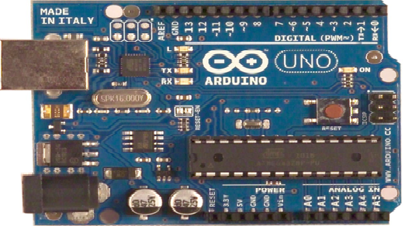
Figure 3.2: Arduino Board
You can deal with your board obliges as far as expert vocation a procedure of rules to the microcontroller on the board by methods for Arduino IDE (recommended as exchanging programming). Not at all like most before programmable circuit sheets, Arduino does not require an extra piece of hardware (called a thing diagram) with a particular veritable objective to stack another code onto the board. You can basically use a USB relate. Also, the Arduino IDE uses a streamlined difference in C++, making it less requesting to appreciate how to program. Finally, Arduino gives a traditional bundling factor that breaks the parts of the cut back scale controller into a more open package.
ATmega328P-PU with Arduino Boot loader
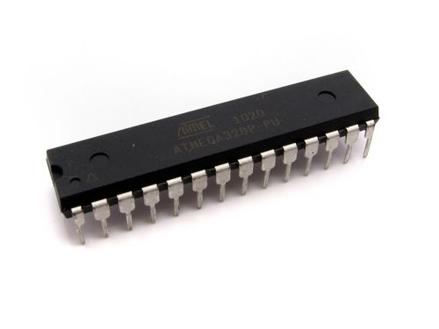
Figure 3.3: ATmega328P-PU
Description:
The name says everything on this one. An Atmega328 in DIP bundle, pre-stacked with the Arduino (16MHz) Boot loader. This will engage you to utilize Arduino code in your especially presented connects without using a genuine Arduino board.
To get this chip working with Arduino IDE, you will require an outside 16MHz significant stone or resonator, a 5V supply, and a serial association. On the off chance that you are not content with doing this, we propose acquiring the Arduino Duemilanove board that has these merged with the board.
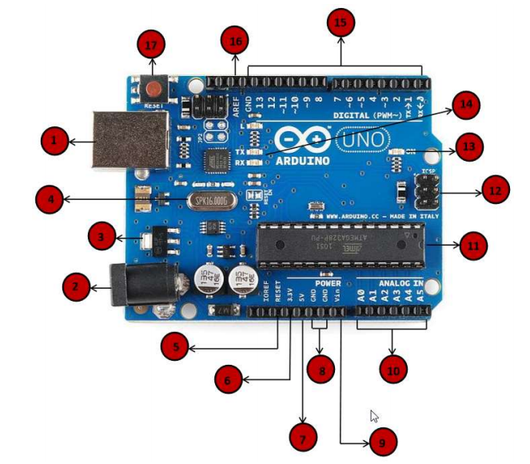
Figure 3.4: Pin Description of Arduino
- Power USB: Arduino board can be engaged by using the USB interface from your PC. You should basically relate the USB interface with the USB union (1).
- Power (Barrel Jack): Arduino sheets can be filled particularly from the AC mains control supply by assistant it to the Barrel Jack (2).
- Voltage Regulator: The most distant purpose of the voltage controller is to control the voltage given to the Arduino board and parity the DC voltages used by the processor and diverse areas.
- Gem Oscillator: The gainful stone oscillator helps Arduino in overseeing time issues. How does Arduino discover time? The most ideal reaction is, by using the noteworthy stone oscillator. The number engraved over the Arduino critical stone is 16.000H9H. It reveals to us that the repeat is 16,000,000 Hertz or 16 MHz.
- Arduino Reset: You can reset your Arduino board, i.e., start your program from the most reliable beginning stage. You can reset the UNO board in two different ways. Regardless, by using the reset get (17) on the board. Second, you would interface have the ability to an outside reset catch to the Arduino stick named RESET (5).
6,7,8,9 Pins (3.3, 5, GND, Vin) 3.3V (6): Supply 3.3 yield volt
- 5V (7): Supply 5 yield volt
- Most of the parts used with Arduino board works fine with 3.3-volt5-volt GND (8) (Ground): There are a few GND sticks on the Arduino, any of which it tends to be used to ground your circuit. Vin (9): This stick in like way can be used to control the Arduino board from an outside power source, like AC mains control supply.
- Direct sticks: The Arduino UNO board has five clear data pins A0 through A5. These pins can read the flag from a reasonable sensor like the moisture sensor or temperature sensor and change over it into an electronic regard that can be broke down by the chip.
- Primary Controller: Each Arduino board has its own specific microcontroller (11). You can remember it as the cerebrum of your board. The essential IC (joined circuit) on the Arduino is somewhat not definitely the equivalent as board to board. The microcontrollers are generally of the ATMEL Company. You ought to perceive what IC your ban has before stacking another program from the Arduino IDE. This information is open on the most astounding explanation behind the IC. For more bits of finding out about the IC movement and purposes of restriction, you can propose the data sheet.
- ICSP stick: For the most part, ICSP (12) is an AVR, an unassuming programming header for the Arduino containing MOSI, MISO, SCK, RESET, VCC, and GND. It is as frequently as conceivable proposed as a SPI (Serial Peripheral Interface), which could be considered as an "extension" of the yield. If all else fails, you are slaving the yield contraption to the expert of the SPI transport.
- Power LED pointer: This LED ought to light up when you relate your Arduino to a power source to demonstrate that your blockade is empowered certainly. If this light does not turn on, by then there is a vital issue with the affiliation.
- TX and RX LEDs: On your board, you will find two names: TX (transmit) and RX (get). They appear in two places on the Arduino UNO board. Regardless, at the robotized pins 0 and 1 display the pins accountable for sequential correspondence. Second, the TX and RX drove (13). The TX drove flashes with different speed while sending the sequential data. The speed of shooting depends on the baud rate used by the board. RX flashes in the midst of the getting method.
- Computerized I/O: The Arduino UNO board has 14 electronic I/O pins (15) (of which 6 give PWM) (Pulse Width Modulation) yield. These pins can be dealt with to fill in as data electronic pins to look at procedure for speculation regards (0 or 1) or as forefront yield pins to drive particular modules like LEDs, exchanges, et cetera. The pins stamped "~" can be used to make PWM.
- AREF: Remain for Analog Reference. It is on occasion, used to set an external reference voltage (in the region of 0 and 5 Volts) past what many would consider attainable for the reasonable data stick.
Pin diagram:
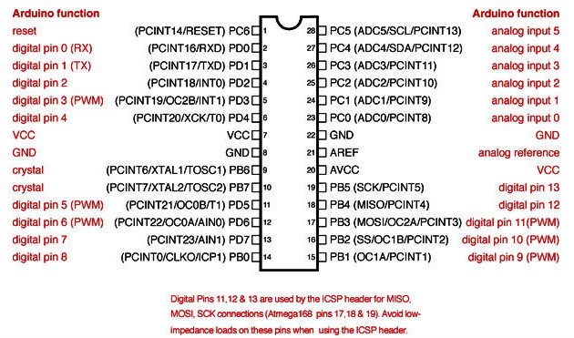
Figure 3.5: Pin diagram of Arduino

Specialized Specifications:
Microcontroller ATmega328
Working Voltage 5V
Information Voltage(recommended) 7-12V
Info Voltage (limits) 6-20V
Computerized I/O Pins 14 (of which 6 give PWM yield)
Simple Input Pins 6
DC Current per I/O Pin 40 mA
DC Current for 3.3V Pin 50 mA
Streak Memory 32 KB (ATmega328) of which 0.5
SRAM 2 KB (ATmega328)
EEPROM 1 KB (ATmega328)
Clock Speed 16 MHz

5.4 POWER SUPPLY

Figure 5.9: Power Supply
The information to the circuit is related from the arranged power supply. The AC information i.e., 230v from the mains give is wind around the transformer to 12v and is lively to a rectifier. The yield grabbed from the rectifier is a sore DC voltage. Remembering the true objective to get an unmodified DC voltage, the yield voltage from the rectifier is supported to a channel to leave any AC parts introduce widely after refresh. Inevitably, this voltage is given to a voltage controller to get an immaculate unfaltering dc voltage.
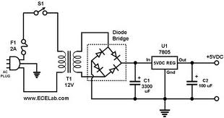
Figure 5.10: Circuitdiagramof LPC2148
The Arduino Uno can be filled by techniques for the USB association or with an outside power supply. The power source is picked consequently. Outside (non-USB) power can come either from an AC-to-DC connector (divider wart) or battery. The connector can be connected by ending a 2.1mm focus positive interface with the board's essentialness jack. Leads from a battery can be embedded in the Gnd and V_{in} stick headers of the POWER connector.
The board can wear down an outer supply of 6 to 20 volts. In the event that gave under 7V, regardless, the 5V stick may supply under five volts and the board might be unsafe. In the event that utilizing more than 12V, the voltage controller may overheat and hurt the board. The prescribed run is 7 to 12 volts.
The power pins are as per the going with
- V_{IN}: The information voltage to the Arduino board when it's utilizing an outside power source (instead of 5 volts from the USB association or other supervised control source). You can supply voltage through this stick, or, if giving voltage by techniques for the power jack, get to it through this stick.
- 5V: The facilitated control supply used to control the microcontroller and differing parts on the board. This can come either from VIN by techniques for an on-board controller, or be given by USB or another planned 5V supply.
- 3.3V: A 3.3 volts supply conveyed by the on-board controller. Most ludicrous current draw is 50 mA.
- GND: Ground pins.
Transformer:
When in doubt, DC voltages are obliged to work diverse electronic apparatus and these voltages are 5/9/12 Volts. In any case these voltages can't be gotten arrange.
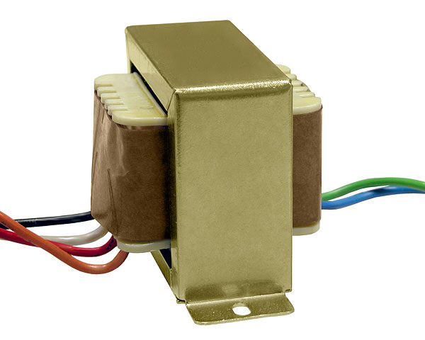
Figure 5.11: Step-down Transformer
In this way the AC information open at the mains supply i.e., 230Volts is to be cut down to the obliged voltage level. This is done by a transformer. Along these lines, a wander down transformer is used to diminish the voltage to an obliged level.
Rectifier:
The yield from the transformer is made sense of how to the rectifier. It changes over AC. into throbbing DC. The rectifier might be a half wave or a full wave rectifier. In this broaden, a phase rectifier is used by brilliance of its purposes of intrigue like awesome reliability and full wave change.
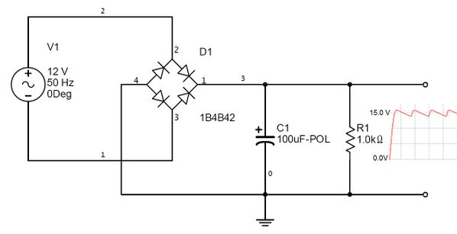
Figure 5.12: Full wave Bridge Rectifier
Filter:
Capacitive channel is used as a touch of this wander. It removes the swells from the yield of rectifier and smoothens the Dc. Yield got from this channel is relentless until the mains voltage and weight is kept up reliable. On the other hand, if both of the two is changed, Dc. voltage got starting at the present moment changes. Along these lines a controller is connected at the yield make.
Voltage Controller:
Figure 5.13: Voltage Regulator
A voltage controller is an electrical controller planned to thusly keep up a persevering voltage level. In this wind, control supply of 5v and 12v are required. Remembering the true objective to get these voltage levels, 7805 and 7812 voltage controllers are to be used.
Memory:
The Atmega328 has 32 KB of glimmer memory for securing code (of which 0,5 KB is utilized for the boot loader); It has in like way 2 KB of SRAM and 1 KB of EEPROM.
Communication:
The Arduino Uno has different workplaces for talking with a PC, another Arduino, or diverse microcontrollers. The ATmega328 gives UART TTL (5V) serial correspondence, which is available on electronic pins 0 (RX) and 1 (TX). An ATmega16U2 on the board channels this serial correspondence over USB and appears as a virtual com port to programming on the PC. The '16U2 firmware uses the standard USB COM drivers, and no external driver is required. Nevertheless, on Windows, an .info record is required.
The Arduino programming consolidates a serial screen which empowers fundamental printed data to be sent to and from the Arduino board. The RX and TX LEDs on the board will streak when data is being transmitted through the USB-to-serial chip and USB relationship with the PC (however not for serial correspondence on pins 0 and 1).
A Software Serial library thinks about serial correspondence on any of the Uno's propelled pins. The ATmega328 in like manner supports I2C (TWI) and SPI correspondence. The Arduino programming fuses a Wire library to streamline use of the I2C transport; see the documentation for purposes of intrigue. For SPI correspondence, use the SPI library.
USB Over current Protection:
The Arduino Uno has a resettable polyfused that shields your PC's USB ports from shorts and overcurrent. Though most PCs give their own specific inside confirmation, the breaker gives an extra layer of security. If more than 500 mA is associated with the USB port, the circuit will normally break the relationship until the point that the short or over-load is removed.
Physical Characteristics:
The best length and width of the Uno PCB are 2.7 and 2.1 inches independently, with the USB connector and power jack extending past the past estimation. Four screw holes empower the board to be joined to a surface or case. Note that the partition between electronic pins 7 and 8 is 160 mil (0.16"), not an even unique of the 100-mil scattering of exchange pins.
5.5 LIQUID CRYSTAL DISPLAY (LCD)
LCD stays for Liquid Crystal Display. LCD is finding extensive utilize supplanting LEDs (seven-piece LEDs or other multi segment LEDs) because of the going with reasons:
- The declining expenses of LCDs.
- The ability to indicate numbers, characters and plan. This is instead of LEDs, which are obliged to numbers and a few characters.
- Consolidation of a fortifying controller into the LCD, in this way easing the CPU of the task of resuscitating the LCD. Strikingly, the LED must be restored by the CPU to keep demonstrating the data.
- Simplicity of programming for characters and outline. These are used for arraigning specific messages on a little scale LCD.
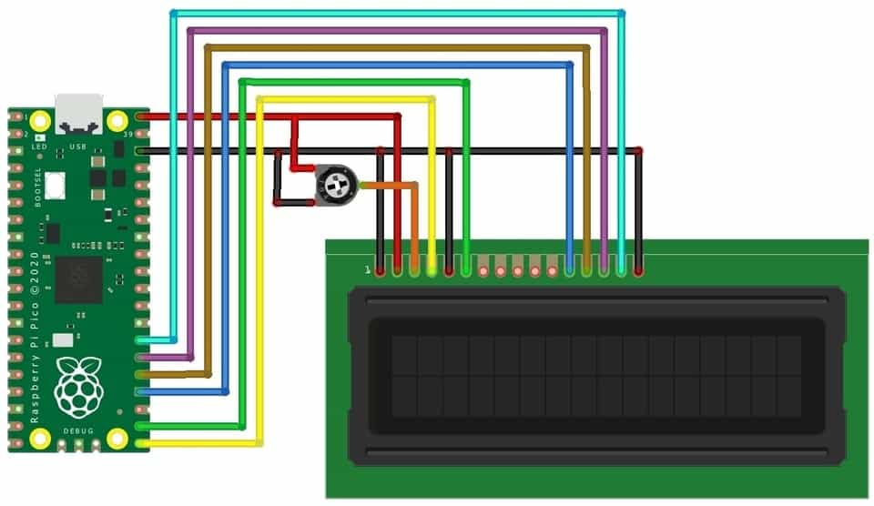
Figure 5.14: LCD Module
Pin Functions:
Pin No | Function | Name
1 | Ground (0V) | Ground
2 | Supply voltage; 5V (4.7V – 5.3V) | V_{CC}
3 | Contrast adjustment; through a variable resistor | V_{EE}
4 | Selects command register when low;  and data register when high | Register Select
5 | Low to write to the register; High to read from the register | Read/write
6 | Sends data to data pins when a high to low pulse is given | Enable
7 | 8-bit data pins | DB0
8 |  | DB1
9 |  | DB2
10 |  | DB3
11 |  | DB4
12 |  | DB5
13 |  | DB6
14 |  | DB7
15 | Backlight V_{CC} (5V) | Led+
16 | Backlight Ground (0V) | Led-
Table 5.2: Pin functions of LCD
LCD Screen:
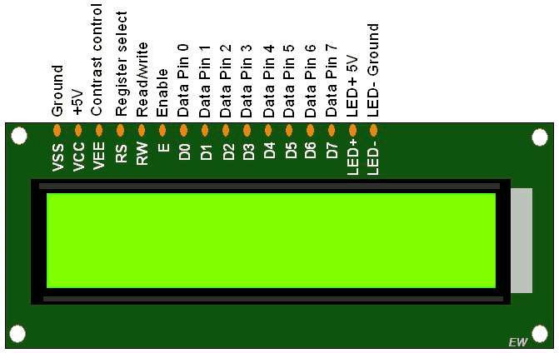
Figure 5.15:Liquid Crystal Display
LCD Basic Commands:
Passage mode set order
These gather sets cursor move bearing and show proceed onward/OFF. There are 4 possible limit set commands;04, 05, 06, and 07. This request modifies the course the cursor moves by setting the convey counter to expansion or decrement. This request is basic. If you don't understand it you may not see anything or what you extremely expected to see on LCD screen. I have made 4 vivified gifs to indicate what the limit set charge is about.
Exactly when my partner HakanDereli expected to get some answers concerning LC demonstrates I gave him a LC appear and the 4*4 support that I used with my Z80 framework. The support relies upon a 74C922 chip and my circuit to change over the 4-bit data yield of the 74C922 to 8-bit information. It moreover has 3 distinct gets on it. This makes it exceptional to investigate diverse roads in regards to LCDs by entering charges/data physically. Hakan attempted each and every possible bring by sending each one of the numbers in the region of 00h and FFh to the LCD to check whether there is an undocumented part and see how all charges work. He didn't find anything undocumented, yet he saw how LCD carries on after every limit set call. The accompanying are the gifs to demonstrate those requests. To show the effect of every limit set charge it is normal that the LCDs underneath are 2*16 LC Displays with DD RAM convey set to 8 and underline cursor ON. Observe that when the convey counter is set to DECREMENT, strings sent to the LCD will be engraved in reverse demand. A comparable thing applies to the CG RAM, moreover.
- Clear Display.
- Cursor Home. RS R/W DB7 DB6 DB5 DB4 DB3 DB2 DB1 DB0 0 1 * Returns the cursor to the home position (Address 0). Returns show to its unique state on the off chance that it was moved.
- Entry Mode Set.
- Display ON/OFF.
- Cursor and Display Shift.
- Function Set.
- Set CG RAM Address.
- Set DDRAM Address.
16×2 LCD Commands:
Code (Hex) | Working of LCDCommands
1 | Clear display screen
2 | Return home
4 | Decrement cursor (shift cursor to left)
6 | Increment cursor (shift cursor to right)
5 | Shift display right
7 | Shift display left
8 | Display off, cursor off
A | Display off, cursor on
C | Display on, cursor off
E | Display on, cursor blinking
F | Display on, cursor blinking
10 | Shift cursor position to left
14 | Shift cursor position to right
18 | Shift the entire display to the left
1C | Shift the entire display to the right
80 | Force cursor to beginning to 1st line
C0 | Force cursor to beginning to 2nd line
90 | Force cursor to beginning to 3rd line
D0 | Force cursor to beginning to 4th line
38 | 2 lines and 5×7 matrix (8-bit mode)
28 | 2 lines and 5×7 matrix (4-bit mode)
N | Next line
T | Tab
R | Enter
Table 5.3: Commands of LCD
LCD Connection:
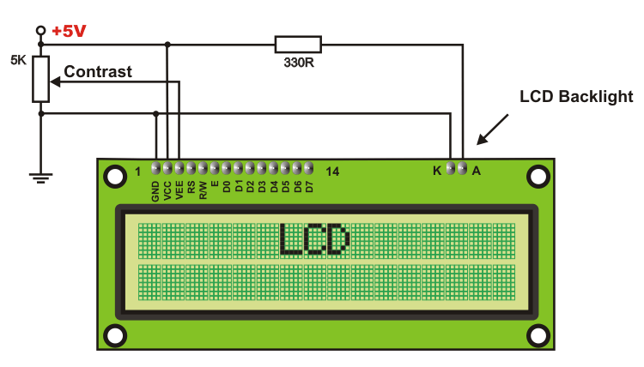
Figure 5.16: LCD Connections
LCD Initialization
- To instate LCD to the microcontroller the accompanying guideline and orders are to be insert into the capacities
- 0×38 is utilized for 8-bit information instatement.
- 0xFH for making LCD on and instating the cursor
- 0x6H for augmenting the cursor which will show another character in the LCD
- 0x1H for clearing the LCD.
- Sending information to the LCD: E=1; empower stick ought to be high
- RS=1; Register select ought to be high to write the information
- Placing the information on the information registers
- R/W=0; Read/Write stick ought to be low to write the information.
5.10 BUZZER
The buzzer emits audible alerts to notify commuters of potential hazards or the activation of the safety grills. It serves as an additional warning mechanism to attract attention. A buzzer or beeper is an audio signaling device, which may be mechanical, electromechanical, or piezoelectric (piezo for short). Typical uses of buzzers and beepers include alarm devices, timers, and confirmation of user input such as a mouse click or keystroke. The helmet is also designed with panic button. This button is used to alarm other workers working at various floors of the large building in case of any disaster or emergency situations. It is designed primarily to intimate every other workers involved in the construction process instantly to avoid large disaster. It is an audio signaling device.

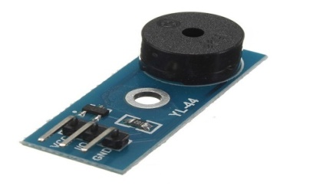
Fig.7: Buzzer

Motor Driver
Motor drivers acts as an interface between the motors and the control circuits. Motor require high amount of current whereas the controller circuit works on low current signals. So the function of motor drivers is to take a low-current control signal and then turn it into a higher-current signal that can drive a motor. Future Electronics has a full programmable motor driver selection from several chip manufacturers that can be used for a motor driver IC(integrated circuit), bipolar stepper motor driver, H bridge motor driver,servo motor driver, DC motor driver, brushless motor driver or for anycircuit that may require a motor driver.Motor driver is shown in Figure (iv)
Simply choose from the motor driver technical attributes below and your search results will quickly be narrowed in order to match your specific motor driver application needs. If you have a preferred brand, we deal with several semiconductor manufacturers such as Free scale Semiconductor, ON Semiconductor , ROHM Semiconductor or STMicroelectronics, among others. You can easily refine your motor driver product search results by clicking your preferred motor driver brand below from our list of manufacturers. Motor drivers can be found in a wide array of applications including Relay and solenoid switching,
- Stepping motor, LED and incandescent displays,
- Automotive applications, Audio-visual equipment, PC Peripherals

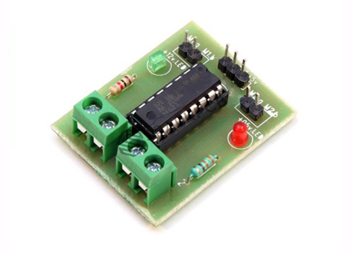
Figure 3.15: Motor driver
L293D is a basic motor driver integrated chip (IC) that enables us to drive a DC motor in either direction and also control the speed of the motor. The L293D is a 16 pin IC, with 8 pins on each side, allowing us to control the motor. It means that we can use a single L293D to run up to two DC motors. L293D consist of two H-bridge circuit. H-bridge is the simplest circuit for changing polarity across the load connected to it. There are 2 OUTPUT pins, 2 INPUT pins, and 1 ENABLE pin for driving each motor. It is designed to drive inductive loads such as solenoids, relays, DC motors, and bipolar stepper motors, as well as other high-current/high-voltage loads.
L293D Description
L293D is a typical Motor driver or Motor Driver IC which allows DC motor to drive on either direction. L293D is a 16-pin IC which can control a set of two DC motors simultaneously in any direction. It means that you can control two DC motor with a single L293D IC. Dual H-bridge Motor Driver integrated circuit (IC). The l293d can drive small and quiet big motors as well, check the Voltage Specification at the end of this page for more info. You can Buy L293D IC in any electronic shop very easily and it costs around 70 Rupees (INR) or around 1 $ Dollar (approx Cost) or even lesser cost. You can find the necessary pin diagram, working, a circuit diagram, Logic description and Project as you read through.
Concept
It works on the concept of H-bridge. H-bridge is a circuit which allows the voltage to be flown in either direction. As you know voltage need to change its direction for being able to rotate the motor in clockwise or anticlockwise direction, Hence H-bridge IC are ideal for driving a DC motor. In a single L293D chip there are two h-Bridge circuit inside the IC which can rotate two dc motor independently. Due its size it is very much used in robotic application for controlling DC motors. Given below is the pin diagram of a L293D motor controller. There are two Enable pins on l293d. Pin 1 and pin 9, for being able to drive the motor, the pin 1 and 9 need to be high. For driving the motor with left H-bridge you need to enable pin 1 to high. And for right H-Bridge you need to make the pin 9 to high. If anyone of the either pin1 or pin9 goes low then the motor in the corresponding section will suspend working. It’s like a switch.
Circuit Diagram For l293d motor driver IC controller.
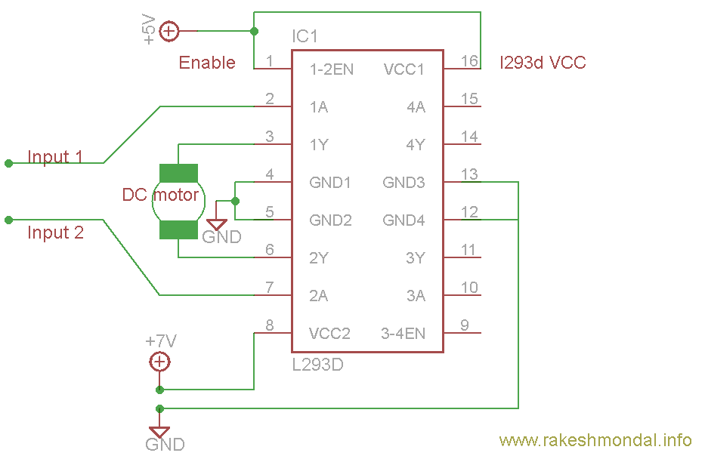
Voltage Specification
VCC is the voltage that it needs for its own internal operation 5v; L293D will not use this voltage for driving the motor. For driving the motors it has a separate provision to provide motor supply VSS (V supply). L293d will use this to drive the motor. It means if you want to operate a motor at 9V then you need to provide a Supply of 9V across VSS Motor supply.
The maximum voltage for VSS motor supply is 36V. It can supply a max current of 600mA per channel. Since it can drive motors Up to 36v hence youcan drive pretty big motors with this l293d
6.1 SOFTWARE REQUIREMENTS
Arduino 1.0.6 software tools used to program microcontroller. The working of software tool is explained below in detail.
Programming Microcontroller
A compiler for an abnormal state dialect decreases generation time. To program the Arduino UNO microcontroller the Arduino is utilized. The writing computer programs is done entirely in the installed C dialect. Arduino is a suite of executable, open-source programming advancement devices for the microcontrollers facilitated on the Windows stage.
Arduino is a device for appearing well and good and control a greater amount of the physical world than your desktop PC. It's an open-source physical registering stage in view of a straightforward microcontroller board, and an improvement domain for composing programming for the board.
One of the challenges of programming microcontrollers is the restricted measure of assets the developer needs to manage. In PCs assets, for example, RAM and preparing speed are essentially boundless when contrasted with microcontrollers. Conversely, the code on microcontrollers ought to be as low on assets as could reasonably be expected
About Arduino Compiler
Get an Arduino board and USB cable:
You additionally require a standard USB link (An attachment to B plug): the kind you would associate with a USB printer, for instance. (For the Arduino Nano, you'll require an A to Mini-B link.)

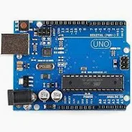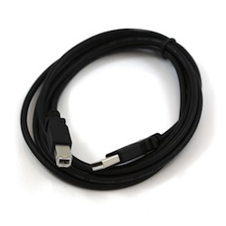
Figure6.1: ArduinoBoard and USB Cable
Connect the board:
The Arduino Uno, Mega, Duemilanove and Arduino Nano consequently draw control from either the USB association with the PC or an outer power supply. In case you're utilizing an ArduinoDiecimila, you'll have to ensure that the board is configured to draw control from the USB association.
The power source is chosen with a jumper, a little bit of plastic that fits onto two of the three sticks between the USB and power jacks. Watch that it's on the two sticks nearest to the USB port. Associate the Arduino board to your PC utilizing the USB link. The green power LED (named PWR) ought to go on.


Figure6.2: Connect the board
Open the blink example
Open the LED blink example sketch: File > Examples >1.Basics> Blink.
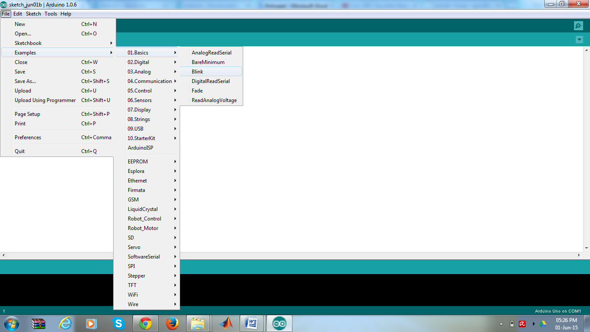
Figure6.3: Opening Blink Example
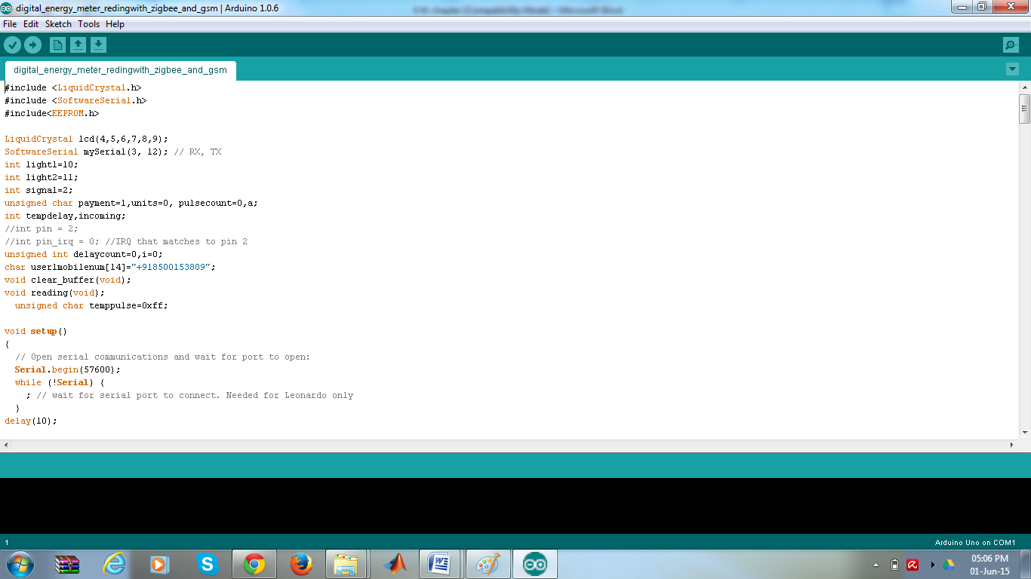
Figure6.4: Source Code Written inArduino Compiler
Select your board:
You'll need to select the entry in the Tools > Board menu that corresponds to your Arduino.
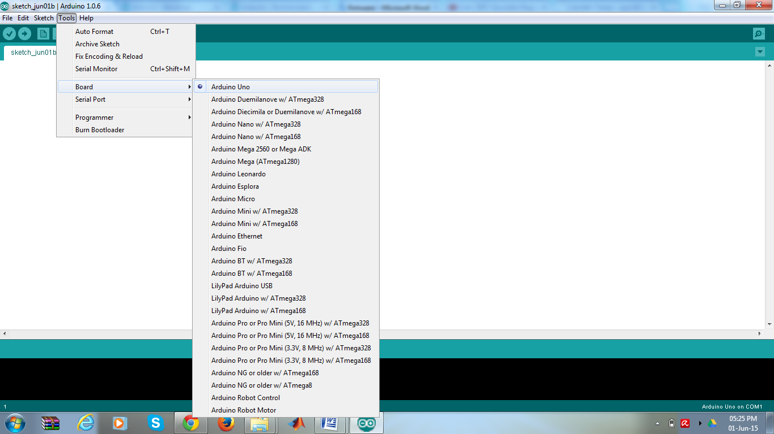
Figure6.5: Selecting an Arduino Uno
Writing Sketches:
Software written using Arduinoare called sketches. These sketches are written in the text editor. Sketches are saved with the file extension.ino. It has features for cutting/pasting and for searching/replacing text. The message area gives feedback while saving and exporting and also displays errors. The console displays text output by the Arduino environment including complete error messages and other information. The bottom right-hand corner of the window displays the current board and serial port. The toolbar buttons allow you to verify and upload programs, create, open, and save sketches, and open the serial monitor.
NB: Versions of the IDE prior to 1.0 saved sketches with the extension.pde. It is possible to open these files with version 1.0, you will be prompted to save the sketch with the.ino extension on save.
Check
Checks your code for mistakes.
Transfer
Assembles your code and transfers it to the Arduino I/O board. See transferring beneath for subtle elements.
Note: If you are utilizing an outer software engineer, you can hold down the "move" key on your PC when utilizing this symbol. The content will change to "Transfer utilizing Programmer"
New
Makes another draw.
Open
Presents a menu of all the representations in your sketchbook. Clicking one will open it inside the present window.
Note: because of a bug in Java, this menu doesn't scroll; on the off chance that you have to open a portray late in the rundown, utilize the File | Sketchbook menu.
Spare
Recoveries your outline.
SerialMonitor
Opens the serial screen.
Table6.1: Writing Sketches
Extra charges are found inside the five menus: File, Edit, Sketch, Tools, Help. The menus are setting delicate which implies just those things applicable to the work as of now being done are accessible.
Select your serial port:
Select the serial gadget of the Arduino board from the Tools | Serial Port menu. This is probably going to be COM3 or higher (COM1and COM2 are typically saved for equipment serial ports). To discover, you can disengage your Arduino board and re-open the menu; the section that vanishes ought to be the Arduino board. Reconnect the board and select that serial port.
Upload the program:
Before transferring your portray, you have to choose the right things from the Tools > Board and Tools > Serial Port menus. The sheets are depicted beneath. On the Mac, the serial port is most likely something like/dev/tty.usbmodem241 On Windows, it's presumably COM1 or COM2 (for a serial board) or COM4, COM5, COM7, or higher (for a USB board) - to discover, you search for USB serial gadget in the ports segment of the Windows Device Manager.
On Linux, it ought to be/dev/ttyUSB0,/dev/ttyUSB1 or comparable.
Once you've chosen the right serial port and board, press the transfer catch in the toolbar or select the Upload thing from the File menu. Current Arduino sheets will reset naturally and start the transfer. With more established sheets (pre-Diecimila) that need auto-reset, you'll have to press the reset catch on the board just before beginning the transfer. On most sheets, you'll see the RX and TX LEDs flicker as the portray is transferred. The Arduino condition will show a message when the transfer is finished, or demonstrate a blunder.
When you transfer a portray, you're utilizing the Arduinobootloader, a little program that has been stacked on to the microcontroller on your board. It enables you to transfer code without utilizing any extra equipment. The bootloader is dynamic for a couple of moments when the board resets; at that point it begins whichever outline was most as of late transferred to the microcontroller. The bootloader will squint the on-board (stick 13) LED when it begins (i.e., at the point when the board resets).

Presently, just tap the "Transfer" catch in the earth. Hold up a couple of moments - you should see the RX and TX leds on the board blazing. In the event that the transfer is fruitful, the message "Done transferring." will show up in the status bar. (Note: If you have an Arduino Mini, NG, or other board, you'll have to physically exhibit the reset catch on the board promptly before squeezing the transfer catch.)
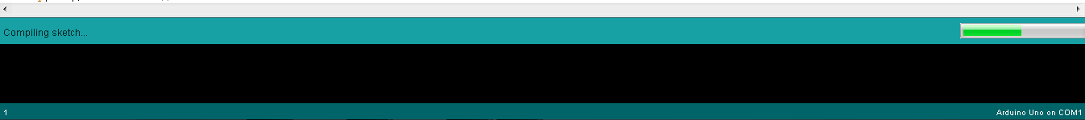
Figure6.6: Compilation under Process
A couple of moments after the transfer completes, you should see the stick 13 (L) LED on the board begin to flicker (in orange). In the event that it does, congrats! You've gotten Arduino up-and-running.

CHAPTER 6
RESULTS AND DISCUSSIONS

.

CHAPTER 7
CONCLUSION AND FUTURE SCOPE
7.1 CONCLUSION
The emotion-based load fan speed control system using facial expression recognition presents a smart and user-friendly approach to appliance automation. The developed system successfully combines camera-based face capture, Python-based emotion detection, Arduino-controlled hardware operation, and automatic fan speed regulation in a single integrated model. By using facial emotion as the control input, the system moves beyond traditional manual and sensor-based methods and introduces a more personalized form of automation.
The proposed system is able to detect selected emotions such as anger, sadness, and happiness and generate the corresponding hardware response. When anger is detected, the fan runs at high speed with red LED indication. When sadness is detected, the fan operates at medium speed with yellow LED indication. When happiness is detected, the fan remains OFF with green LED indication. The LCD display further improves usability by showing the detected emotion and system status in real time. This demonstrates that emotional information can be effectively translated into appliance control actions.
The project proves that facial emotion recognition can be practically integrated with embedded control systems for developing intelligent applications. It reduces manual effort, improves comfort, and creates a more interactive relationship between the user and the appliance. The use of low-cost components such as Arduino Uno, webcam, motor driver, LEDs, and LCD also makes the system suitable for academic implementation and prototype development. Overall, the work highlights the potential of combining artificial intelligence, computer vision, and automation for building human-centered smart systems.
FUTURE SCOPE
The proposed system can be further improved in several ways to increase its performance, flexibility, and real-world applicability. One possible enhancement is the inclusion of more emotional categories such as fear, surprise, disgust, and neutral state, so that the system can respond more accurately to different user conditions. Improved deep learning models can also be used to increase the accuracy and reliability of facial emotion recognition under varying lighting conditions and facial orientations.
Another important future extension is the integration of the system with IoT technology. By connecting the fan control unit to a wireless network, the system can support remote monitoring, cloud-based data storage, and mobile application control. This would make the system more suitable for advanced smart home environments. In addition, the same emotion-aware control concept can be extended to other household appliances such as lights, air conditioners, alarms, and music systems to create a complete emotion-based smart home ecosystem.
Future work may also focus on implementing the emotion detection model on compact edge devices such as Raspberry Pi or TinyML-supported platforms, reducing the dependence on a laptop or computer. Personalized mapping between user emotion and appliance response can also be developed, since comfort preferences may differ from person to person. With these improvements, the system can become more efficient, adaptive, and practical for real-time human-centered automation applications.
.
.
.
.

REFERENCES
- Hadjar, H., et al. “TheraSense: Deep Learning for Facial Emotion Analysis in Teleconsultation.” Electronics, vol. 14, no. 3, 2025, Article 422.
- Bai, M., et al. “Lightweight Emotion Analysis Solution Using Tiny Machine Learning.” Computers & Electrical Engineering, 2025.
- Sone, Y., et al. “Development of a Control Support System for Smart Homes.” Robomech Journal, 2025.
- Addow, M. A., et al. “A Low-Cost IoT-Based Smart Home Automation System for Urban Environments.” Discover Internet of Things, 2025.
- Aleran, A., et al. “Artificial Intelligence and the Internet of Things in Energy Preservation.” Computing, 2025.

APPENDIX
EMBEDDED ‘C’ – PROGRAMMING CODE
This is an Embedded C Programming Code used in my project “Emotion-Based Fan Speed Control System Using Facial Expression Recognition”. This code dumped into ESP 32 Microcontroller by using USB cable to connect the hardware components like esp8266 and sensors through the BLYNK IOT online platform.
BLYNK IOTis an BLYNK IOT Application Enablement Platform (AEP) enabling System Integrators (SIs) and SMBs to rapidly assemble and launch BLYNK IOT applications. BLYNK IOT building blocks include drag-and-drop dashboards, device-friendly APIs, analytics, reports and alerts.
Programming code:

